Article
Hybrid Learning-Assisted LiDAR Crop-Row Navigation for Autonomous Agricultural Robots under Noisy Field Conditions
Yerik Nugman ¹, Nurtay Albanbay ^{1,*}, Azamat Mustafa ¹, Mukhagali Sagyntay ¹, Algazy Zhauyt ³, Rustem Kaiyrov ², Rinat Ilesibekov¹ and Yerlan Ayapov¹
¹ Department of Mechanical Engineering, Satbayev University, 050000 Almaty, Kazakhstan; y.nugman@satbayev.university (Y.N.); a.mustafa@satbayev.university (A.M.); mukhagali.sagyntay@gmail.com (M.S.); n.albanbay@satbayev.university (N.A.)
² Laboratory of Applied Mechanics and Robotics, Karaganda Buketov University, 100001 Karaganda, Kazakhstan; kairov.rustem@mail.ru (R.K.)
³ Department of Aerospace and Electronic Engineering, Almaty University of Power Engineering and Telecommunications, 050013 Almaty, Kazakhstan; a.zhauyt@aues.kz (A.Zh.)
* Correspondence: n.albanbay@satbayev.university
Abstract
Autonomous navigation is a key requirement for agricultural mobile robots operating between crop rows, especially in field environments where GPS signals may be unreliable and camera-based perception can be affected by illumination changes, shadows, and plant appearance variability. This study presents a hybrid learning-assisted and reliability-aware LiDAR crop-row navigation framework for autonomous agricultural robots under noisy field conditions. The proposed approach first processes LiDAR point measurements using region-of-interest selection, geometric preprocessing, and a lightweight cluster-level row classification module (GroveNet) trained from heuristically labeled point clusters. The filtered row-related points are then used for robust crop-row line extraction, scan-level reliability assessment, inter-row centerline estimation, one-row fallback handling, and temporal stabilization of lateral and heading errors. These navigation-ready variables are converted into offline control commands for evaluating stable inter-row motion under clean, semi-dense, and degraded row conditions. The method is designed to support GPS-independent navigation in structured agricultural fields with incomplete and irregular plant distributions while avoiding fully supervised point-level annotation. The expected contribution of the study is a reproducible hybrid LiDAR navigation framework that combines learning-assisted point filtering with interpretable geometric row estimation to improve row-following stability under realistic field conditions.
Keywords: LiDAR-based navigation; crop-row detection; autonomous agricultural robots; learning-assisted filtering; heuristic cluster labeling; cluster-level row classification; reliability-aware navigation; one-row fallback; temporal stabilization; precision agriculture

1. Introduction
Autonomous navigation is a fundamental requirement for precision agriculture because mobile robots must move reliably between crop rows while performing monitoring, spraying, mapping, or weeding operations. Stable crop-row following is especially important in field environments where GPS signals may be unreliable and camera-based perception can be affected by illumination changes, shadows, repetitive row patterns, weeds, outliers, and missing plants.

1.1. Background and Motivation
Agricultural robotics has become an important direction in precision agriculture because modern farms require higher productivity, reduced labor dependence, and more selective use of resources. Mobile robots are increasingly considered for crop monitoring, spraying, harvesting, fruit mapping, and targeted weed-control tasks, where they must operate repeatedly in structured but variable field environments [1-6]. For these operations, navigation between crop rows is not only a mobility problem; it is a prerequisite for stable sensing, safe motion, and accurate execution of field operations.
Autonomous crop-row navigation has been studied through several sensing and control strategies, including GNSS-based guidance, machine vision, depth sensing, fuzzy control, visual servoing, and hybrid navigation frameworks [7-16]. These studies show that agricultural navigation is strongly linked to row detection quality, sensor reliability, and the ability of the control system to convert perceived row structure into stable steering commands.
Within this research area, LiDAR-based navigation is especially relevant because LiDAR directly measures geometric structure and is less dependent on illumination than passive vision sensors. Previous studies have used 2D and 3D LiDAR data for crop-row line extraction, orchard in-row navigation, particle-filter-based localization, and online row following [17-22]. Recent over-canopy and under-canopy navigation studies further show that LiDAR can support row-structure perception when GNSS or camera-only navigation is unreliable, although semantic ambiguity and sparse geometry remain important challenges [23-25].
The robustness of LiDAR-based crop-row navigation is also related to broader problems in geometric model fitting, localization, and mapping. Methods such as energy-based multi-model fitting, scan matching, LiDAR odometry, loop closure, and SLAM provide useful tools for extracting structure and reducing drift in repetitive outdoor environments [26-33]. Recent Gaussian-splatting, visual-LiDAR SLAM, and simulation-based agricultural mapping studies further highlight the importance of combining geometric consistency with agricultural scene structure under occlusion, repeated rows, and seasonal variation [34-39].
In this study, the practical evaluation is designed around a public dataset rather than a newly collected physical field experiment. The CitrusFarm Dataset provides multimodal agricultural robotics data collected by a wheeled mobile robot in citrus tree fields, including LiDAR, wheel odometry, IMU, GPS-RTK, and multiple imaging modalities [40]. Using this dataset supports reproducible evaluation of LiDAR-based crop-row navigation under realistic agricultural conditions while avoiding the cost and variability of a new field-data collection campaign.

1.2. Problem Statement
LiDAR-based crop-row navigation methods commonly rely on the geometric structure of planted rows to estimate the robot's position within the inter-row corridor [17-22]. This makes LiDAR attractive for agricultural navigation because it provides direct range measurements and is less dependent on visual texture or illumination than camera-only approaches. However, the practical performance of LiDAR-based row navigation depends strongly on the quality, density, and continuity of the measured point structure.
A key limitation of existing LiDAR-based approaches is their dependence on sufficiently clear and continuous row geometry. In real agricultural fields, LiDAR scans may contain missing plant sections, row gaps, weeds, soil returns, tree trunks or branches, and isolated outlier points. These factors distort the apparent row structure and can reduce the reliability of line extraction, row-center estimation, and heading estimation. Even robust line-fitting and model-fitting methods may become unstable when the number of valid row points is small or when non-row objects dominate the scan [26-28]. Similar difficulties are also observed in orchard environments, where repetitive row geometry, occlusions, vegetation motion, and seasonal changes complicate localization and mapping [34-38].
Therefore, the main technical problem addressed in this study is the robust extraction of crop-row geometry from noisy and incomplete LiDAR measurements. The problem is not limited to detecting row lines; the detected geometry must also be transformed into navigation-relevant variables, including the inter-row centerline, lateral deviation, and heading error of the robot. In this work, the problem is studied using recorded LiDAR sequences from the CitrusFarm Dataset, which enables evaluation under realistic agricultural field conditions without conducting a new physical field-data collection campaign [40].

1.3. Research Gap
Although LiDAR-based crop-row navigation has been investigated in several studies, important gaps remain in the robustness of existing approaches under realistic field conditions. Geometry-based methods are attractive because they are interpretable and computationally efficient, but they often depend on sufficiently continuous row points and can become unstable when weeds, missing plants, branches, ground returns, or sparse LiDAR measurements dominate the scan [17-22].
Learning-based crop-row perception methods can improve row or plant-structure extraction when suitable training data are available, but fully supervised approaches usually require manually annotated images, point clouds, or crop-specific retraining. This creates a practical gap for agricultural navigation systems that must operate with limited annotation effort while still producing reliable navigation variables from noisy LiDAR measurements.
Another gap concerns the link between point-level perception quality and navigation-ready behavior. Existing methods may detect row-like structures, but they do not always explicitly decide whether a scan is reliable enough for control, how the centerline should be estimated when only one row boundary is visible, or how lateral and heading errors should be stabilized across consecutive scans. These issues are critical in orchards and row-crop fields where row geometry can be incomplete or temporarily occluded.
Thus, the research gap addressed in this study is the lack of a reproducible hybrid LiDAR crop-row navigation framework that combines learning-assisted row-point filtering, robust geometric row-line extraction, scan-level reliability assessment, one-row fallback centerline estimation, and temporal stabilization of navigation errors for autonomous agricultural robots operating under imperfect field conditions.

1.4. Scientific Novelty and Contributions
The scientific novelty of this study lies in a hybrid learning-assisted and reliability-aware LiDAR crop-row navigation algorithm designed for noisy and incomplete agricultural field data. The proposed method combines a lightweight cluster-level row classifier (GroveNet) trained from heuristically labeled point clusters with interpretable geometric row estimation, allowing uncertain LiDAR measurements to be converted into stable navigation variables without requiring fully supervised point-level annotation.
The main scientific contributions of this study are as follows.
First, a heuristic geometric labeling strategy is introduced to train a lightweight cluster-level row classifier (GroveNet) for LiDAR crop-row navigation. Point clusters extracted from raw LiDAR frames are labeled as row-vegetation or non-row using a shape-based heuristic rule, enabling learning-assisted cluster filtering while reducing the need for manual point-cloud annotation.
Second, a scan-level reliability-aware row-navigation framework is proposed to evaluate the validity of extracted crop-row geometry before it is passed to the navigation-control stage. The framework uses row-line quality indicators such as inlier count, inlier ratio, row-spacing consistency, and line-orientation consistency to reject unstable LiDAR scans instead of generating control commands from unreliable geometry.
Third, one-row fallback centerline estimation and temporal stabilization of lateral and heading errors are incorporated to maintain navigation continuity when only one row boundary is reliable and to reduce command fluctuations caused by scan-to-scan variation in noisy field measurements.

2. Materials and Methods
This section describes the dataset-based methodology for evaluating the proposed hybrid LiDAR crop-row navigation approach. The proposed algorithm is evaluated using LiDAR sequences collected in citrus orchards as part of the CitrusFarm Dataset. Each LiDAR scan is processed through a navigation-oriented pipeline that includes region-of-interest selection, geometric preprocessing, heuristically labeled cluster-level row classification, robust row-line extraction, scan-level reliability assessment, inter-row centerline estimation, one-row fallback handling, temporal stabilization of lateral and heading errors, and offline command-generation analysis. The section also defines the baseline methods and evaluation metrics used to assess row-detection reliability, navigation-error stability, robustness under degraded field conditions, learning-assisted filtering benefit, and real-time feasibility.

2.1. Dataset-Based Experimental Setup
The experimental setup is defined as an offline dataset-based evaluation using the publicly available CitrusFarm Dataset from the University of California Riverside. The dataset was collected by a Clearpath Jackal wheeled mobile robot in citrus tree fields and provides seven sequences recorded in three fields, with nine sensing modalities, 1.7 h of operation, 7.5 km of robot travel, and approximately 1.3 TB of data [40]. In this study, the recorded Velodyne VLP-16 LiDAR point clouds are used as the primary input for crop-row navigation. Odometry, IMU, and GPS-RTK data are used for timestamp synchronization, trajectory referencing, and consistency checking during offline evaluation. Camera modalities are not used by the proposed method, because the study focuses on LiDAR-based row-geometry extraction and heuristically labeled cluster-level LiDAR filtering rather than image-based crop-row segmentation.

2.2. LiDAR Data Selection and Scenario Design
LiDAR data for the evaluation are selected according to the field categories defined in the CitrusFarm Dataset. The dataset provides seven sequences collected from three citrus fields with different planting patterns: Field One has a sparse-uniform structure and includes sequences 01-03; Field Two has a semi-dense in-row structure and includes sequences 04-05; and Field Three has a dense in-row structure and includes sequences 06-07. In this study, these dataset-defined field categories are used as three evaluation scenarios to test whether the proposed hybrid crop-row navigation algorithm remains reliable across increasing row-structure complexity and vegetation density.
The first scenario is the sparse-uniform field condition. It uses LiDAR scans from sequences 01-03, where the tree-row structure is more regular and the inter-row corridor is expected to be more visible. This scenario is used to evaluate the baseline row-line extraction and centerline estimation performance of the proposed method under relatively favorable row-geometry conditions. This scenario is not used to generate GroveNet training labels; label generation instead uses a separate offline auto-labeling procedure applied directly to raw LiDAR frames (Section 2.5), independent of the sparse-uniform, semi-dense, and dense-in-row scenario categories used for navigation-level evaluation.
The second scenario is the semi-dense in-row field condition. It uses LiDAR scans from sequences 04-05, where the robot operates in denser row structure and the continuity of row-boundary points may be reduced by vegetation density, partial occlusion, and irregular point distribution. This scenario is used to evaluate whether geometric preprocessing, learning-assisted row-point filtering, robust line fitting, and scan-level reliability assessment improve row detection when the row geometry is less regular than in the sparse-uniform field.
The third scenario is the dense in-row field condition. It uses LiDAR scans from sequences 06-07, where dense vegetation, overlapping branches, sparse valid row returns, and non-row vegetation may make row-boundary extraction unstable. This scenario is used to test the robustness of the proposed method under the most difficult CitrusFarm field condition, including cases where only one row boundary may be reliably detected and one-row fallback may be required.
For each selected sequence, Velodyne VLP-16 LiDAR frames are processed scan by scan. Each scan is used directly in the sensor's own coordinate frame, treated as coinciding with the robot-centered frame (x-axis forward, y-axis lateral); no LiDAR-to-robot extrinsic calibration is applied to correct for sensor mounting offset or misalignment (Section 4.1). A forward-looking region of interest is then applied to retain only the points located in the navigation-relevant corridor in front of the robot. Points outside this region are excluded before preprocessing and row-line extraction.
The selected scan intervals begin at a fixed offset of 300 scans after the start of each sequence's first recorded bag file, intended to move past robot startup and staging behavior. This offset is a fixed heuristic rather than a validated filter: an RTK-based check (Section 3.7) found that only about 35% of the 1200 evaluated scans correspond to confirmed straight-line row-following, with the remainder covering headland turns and near-stationary maneuvering that the offset does not reliably exclude. Each retained scan is associated with its timestamp, sequence label, and dataset-defined field scenario so that the same scan intervals can be used for the proposed method and for all baseline methods.
The learning-assisted component (GroveNet) is trained independently of these three scenarios, using the offline heuristic cluster-labeling procedure described in Section 2.5, which is applied to raw LiDAR frames from all selected sequences rather than being gated by scan-level row-line reliability. Dense in-row scans are still used primarily for robustness testing at the navigation level (Sections 3.3-3.4).
The output of this stage is a set of LiDAR scan intervals grouped by the dataset-defined sparse-uniform, semi-dense in-row, and dense in-row scenarios. These intervals are used in the following sections to evaluate row-point filtering performance, row-line detection reliability, inter-row centerline stability, lateral and heading error behavior, one-row fallback performance, temporal stabilization, and processing time per scan.

2.3. Proposed Hybrid LiDAR-Based Navigation Pipeline
The proposed hybrid LiDAR-based navigation pipeline is implemented as a scan-by-scan processing procedure applied to recorded CitrusFarm LiDAR sequences. The pipeline converts each raw LiDAR point cloud into navigation-ready variables, including row-point probability estimates, left and right row-boundary estimates, an inter-row centerline, lateral deviation, heading error, a scan reliability flag, and an offline steering correction. The overall structure of the pipeline is shown in Figure 1.
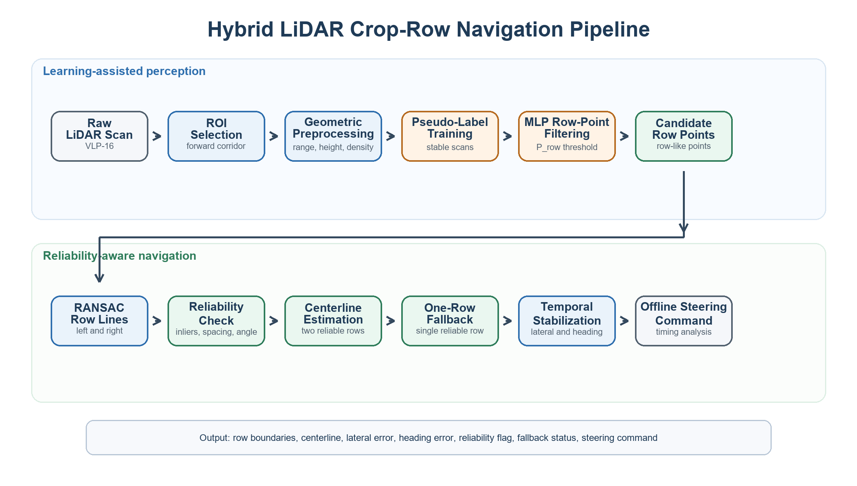
Figure 1. Hybrid LiDAR crop-row navigation pipeline with learning-assisted point filtering and reliability-aware centerline estimation.
First, each LiDAR scan is used in the sensor's own coordinate frame, treated as the robot-centered frame without an explicit extrinsic calibration step (Section 4.1). A forward-looking region of interest is defined in front of the robot and around the expected inter-row corridor. This step removes distant background objects and points outside the navigation area so that the following stages focus on the left and right crop-row structures relevant to robot guidance.
Second, the selected LiDAR points are geometrically preprocessed to reduce measurement noise, isolated outliers, ground returns, weeds, and irregular vegetation returns. This stage applies range-based filtering, height or scan-plane filtering, local-density filtering, and optional downsampling according to the parameter set defined in Table 1.
Third, the point clusters produced by geometric preprocessing are passed through a lightweight cluster-level classification module (GroveNet), trained using heuristically labeled clusters. The classifier assigns each cluster a single row-probability score. Only clusters with sufficient row likelihood are retained, and all their points proceed as candidate row-structure points for geometric line extraction.
Fourth, the retained row-related point cloud is divided into left-row and right-row candidate point sets according to the lateral position of points relative to the robot. RANSAC-based line estimation is then applied separately to both candidate sets to obtain representative left and right crop-row boundaries.
Fifth, each extracted row line is evaluated using scan-level reliability criteria, including inlier count, inlier ratio, row-spacing consistency, and line-orientation consistency. Reliable row lines are used for centerline estimation, while unreliable row lines are rejected before navigation-error computation. Finally, the inter-row centerline, lateral deviation, and heading error are estimated from the accepted row lines. If both row lines are reliable, the centerline is computed from the left and right row boundaries. If only one row line is reliable, a one-row fallback centerline is estimated using the expected row spacing. The lateral and heading errors are temporally stabilized and converted into an offline steering correction for row-following analysis. Because the study uses recorded dataset sequences rather than a closed-loop robot trial, the command is interpreted as a control-ready output and a real-time feasibility indicator rather than as a physically executed motion command.

2.4. LiDAR Point Preprocessing and Outlier Filtering
In this study, LiDAR point preprocessing is implemented as the first filtering stage before learning-assisted cluster classification and crop-row line extraction. The input is a raw Velodyne VLP-16 point cloud from a selected CitrusFarm sequence, and the output is a geometrically cleaned point set that is passed to the GroveNet cluster classifier described in Section 2.5. The preprocessing is performed independently for each scan to support per-scan timing analysis.
The first operation is coordinate framing. Each LiDAR scan is used in the sensor's own coordinate frame: the forward direction of the robot is treated as the longitudinal x-axis, the left-right direction is treated as the lateral y-axis, and the vertical direction is treated as the z-axis. This frame is assumed to coincide with the robot-centered frame; no LiDAR-to-robot extrinsic calibration is applied, and Section 4.1 identifies this as the likely source of a small, systematic lateral bias. Points behind the robot, points outside the forward sensing window, and points outside the useful lateral navigation corridor are removed.
After coordinate framing, a region of interest is applied. The default ROI covers the near-to-mid field region in front of the robot where row geometry is expected to be relevant for immediate navigation. The ROI removes distant trees, background objects, and points that cannot influence the next steering correction.
The next operation is range and height filtering. Points with invalid range values, extremely short distances, and physically unrealistic coordinates are removed. For 3D point clouds, a height interval is used to reduce ground returns and high canopy or branch points that do not represent the row boundary used for inter-row guidance.
To reduce isolated outliers and sparse measurements, a local-density filter is applied. For each point, the number of neighboring points within a fixed radius is counted. Points with fewer than the minimum required neighbors are removed from the candidate set. This step reduces the influence of isolated weed returns, leaf-edge points, and occasional sensor reflections before learning-assisted row-point filtering and robust line fitting.
Finally, the remaining points are optionally downsampled using a voxel-grid procedure to reduce computational cost while preserving the main row geometry. The resulting point set is not treated as the final row structure; instead, it provides a cleaned input for the cluster classifier and the subsequent RANSAC-based row-line extraction stage. The default implementation parameters used to make the pipeline reproducible are summarized in Table 1.

Table 1. Default parameters of the proposed hybrid LiDAR navigation pipeline.
Stage | Parameter | Default value | Purpose
ROI selection | Forward range x | 0.5-8.0 m | Limits analysis to near-to-mid row geometry
ROI selection | Lateral range y | -4.0 to 4.0 m | Keeps points near the expected inter-row corridor
Height filtering | Height interval z | 0.15-2.50 m | Suppresses ground returns and high canopy points
Density filtering | Neighbor radius | 0.30 m | Detects isolated sparse returns
Density filtering | Minimum neighbors | 3 points | Removes isolated outliers before line fitting
Downsampling | Voxel size | 0.10 m | Reduces point count while preserving row structure
RANSAC | Distance threshold | 0.15 m | Defines inliers for candidate row lines
RANSAC | Maximum iterations | 100 | Limits computation time per scan
Reliability check | Minimum inliers | 25 points | Rejects weak row-line estimates
Reliability check | Minimum inlier ratio | 0.35 | Rejects unstable line models
Reliability check | Orientation tolerance | +/-25 deg | Checks consistency with the expected row direction
Command generation | Reference speed v_ref | 0.50 m/s | Defines offline row-following speed
Command generation | Lateral gain k_y | 0.80 rad s^-1 m^-1 | Weights lateral deviation in angular correction
Command generation | Heading gain k_theta | 1.20 s^-1 | Weights heading error in angular correction
Command generation | Angular velocity limit | +/-0.80 rad/s | Bounds steering correction from noisy scans
GroveNet classifier | Input features | 512 points x 4 channels: x, y, z, intensity | Defines fixed-size point-cluster input to GroveNet
GroveNet classifier | Row-probability threshold | 0.5 | Keeps likely row points for RANSAC extraction
Cluster labeling (heuristic) | Minimum cluster points | 30 points | Minimum size for a cluster to be considered row-vegetation
Cluster labeling (heuristic) | Minimum vertical extent (dz) | 0.4 m | Rules out flat ground strips
Cluster labeling (heuristic) | Maximum horizontal extent (dx, dy) | 4.5 m | Rules out merged multi-row blobs
Cluster labeling (heuristic) | Maximum aspect ratio (dz / max(dx,dy)) | 3.0 | Guards against narrow person/pole-shaped objects
Temporal stabilization | Smoothing factor alpha | 0.1 | Balances current scan estimate and previous stable estimate

2.5. Cluster-Level Row Classification (GroveNet)
The learning-assisted filtering stage is placed between geometric preprocessing and RANSAC-based row-line extraction. Geometric preprocessing (Section 2.4) groups the cleaned point cloud into candidate clusters using DBSCAN (neighborhood radius 0.35 m, minimum 8 points per cluster), applied to points within the locally estimated canopy height band. Each cluster is then classified as row-vegetation or non-row by GroveNet, and only points belonging to accepted clusters are retained for line fitting. The classifier operates as a cluster-level filter, not a point-level or end-to-end neural controller.
Because the CitrusFarm Dataset provides no manual cluster-level row labels, training samples and labels are generated by an offline auto-labeling pipeline applied directly to the raw LiDAR frames of each sequence, independent of the online RANSAC row-line estimate. For each frame, points are cropped to a 0.5-10 m radius around the sensor, and a 30-degree rear azimuth sector (180 deg +/- 15 deg) is excluded; this step was added after inspecting the labeled data and finding that an operator walking behind the robot at a near-constant sensor-relative azimuth contaminated around 11% of bush-labeled clusters with a person-shaped object. Ground height is estimated locally, using the 5th percentile of z within 0.4 m x 0.4 m XY grid cells rather than a single global plane, because field terrain is not flat. Points within the same 0.15-2.5 m canopy height band used for online preprocessing (Table 1) are kept as clustering candidates; statistical outliers are removed (12 neighbors, standard-deviation ratio 1.5) before the remaining points are grouped with DBSCAN.
Each DBSCAN cluster is labeled using a geometric shape heuristic (is_bush_cluster, Table 1) rather than a distance-based comparison to fitted row lines. A cluster is labeled row-vegetation when it contains at least 30 points, has a vertical extent of at least 0.4 m (ruling out flat ground strips), has a horizontal footprint (bounding-box extent in both x and y) of at most 4.5 m (ruling out merged multi-row blobs), and has a height-to-width aspect ratio of at most 3.0 (guarding against narrow, person- or pole-shaped objects that fall outside the excluded rear sector). Clusters failing any of these criteria are labeled non-row. This rule identifies citrus-canopy-shaped vegetation in general rather than proximity to a specific row line; within the LiDAR's forward-looking region of interest, such clusters are assumed to predominantly correspond to row-relevant vegetation. Non-row training examples are additionally drawn from DBSCAN noise points (isolated returns) and from the full set of height-band-excluded points (ground layer and above-canopy), tiled into non-overlapping 2.5 m x 2.5 m grid cells with at least 5 points each, so that every excluded point is represented in some training sample.
Each labeled cluster is represented as a fixed-size point set of 512 points with four channels per point (x, y, z, LiDAR intensity), with x, y, z centered on the cluster's own centroid. Clusters with more than 512 points are reduced via farthest-point sampling, which preserves spatial coverage; clusters with fewer points are padded by randomly repeating existing points.
GroveNet processes each cluster with a residual point-based encoder: three residual PointBlocks with 48, 96, and 192 channels, followed by global max- and mean-pooling over the point dimension, concatenation of the two pooled descriptors, and two fully connected layers (64 and 32 units) leading to a sigmoid output neuron that predicts the cluster's row probability P_row. The resulting model has approximately 75K parameters (Table 2).
The model is trained as a binary classifier using the heuristic row/non-row labels, binary cross-entropy loss, and the Adam optimizer, following the same data split, sampling strategy, and training schedule as the baseline models compared in Section 3.1. To reduce data leakage, labeled frames are split by sequence or contiguous scan interval rather than mixing individual clusters from the same frame into both training and validation sets.
During inference, the trained classifier computes P_row for each candidate cluster produced by geometric preprocessing. Clusters with P_row >= 0.5 are retained, and all of their points proceed to RANSAC; clusters below this threshold are discarded entirely. This filtering is expected to increase the RANSAC inlier ratio, reduce false row-line fitting caused by weeds, branches, ground returns, or isolated outliers, and improve the stability of the subsequent centerline and navigation-error estimates.

2.6. Crop-Row Line Extraction
The crop-row line extraction stage converts the filtered LiDAR point set obtained from Sections 2.4 and 2.5 into two geometric models: the left crop-row line and the right crop-row line. This stage is conceptually related to previous LiDAR-only crop navigation work, where a PEARL/Ruby-based line-finding algorithm was used to extract crop-row models before fuzzy control [18]. In this study, the implemented row-extraction method is learning-assisted RANSAC line fitting, selected because it provides a reproducible robust geometric baseline for noisy CitrusFarm LiDAR scans.
The row-probability-filtered point cloud is first separated into left-row and right-row candidate sets in the robot-centered coordinate frame. Points with positive lateral coordinates are assigned to one row side and points with negative lateral coordinates are assigned to the opposite row side, after applying the lateral ROI limits defined in Table 1. Points near the robot centerline can be ignored when they are unlikely to belong to row boundaries.
For each candidate set, RANSAC estimates a two-dimensional line model in the ground-plane projection of the point cloud. In each iteration, two points are sampled to define a candidate line, the perpendicular distance from all candidate points to this line is computed, and points within the 0.15 m distance threshold are treated as inliers. The model with the largest inlier support after 100 iterations is selected as the preliminary row boundary.
After RANSAC selection, the final row line is refined using all inlier points with least-squares fitting. This refinement reduces random variation caused by the initial RANSAC sampling and provides a stable estimate of row direction and row position. The same procedure is applied independently to the left and right candidate sets.
Each extracted line is then checked using scan-level reliability criteria. A row line is accepted only when the number of inliers, inlier ratio, and line orientation satisfy the thresholds in Table 1. If one side contains too few reliable points because of missing plants, partial occlusion, or sparse LiDAR returns, that row line is marked as unreliable for the current scan.
The output of this stage consists of the left row-line parameters, the right row-line parameters, their corresponding inlier point sets, and quality indicators such as inlier count, inlier ratio, and reliability status. These outputs are passed to the next stage, where the inter-row centerline, lateral deviation, and heading error are computed for navigation command generation.

2.7. Row-Center Estimation and Navigation Error Computation
The row-center estimation stage uses the left and right crop-row lines extracted in Section 2.6 to compute the desired navigation path between the rows. The input consists of the accepted left row line, the accepted right row line, and their reliability indicators. The output consists of the inter-row centerline, the robot lateral deviation, and the robot heading error.
In the robot-centered coordinate frame, each row boundary is represented in slope-intercept form as y = a x + b, where a is the row-line slope and b is the lateral intercept at x = 0. This form is adequate here because, within the forward-looking ROI (Table 1), row lines remain roughly aligned with the forward direction rather than near-vertical in the (x, y) scan plane. The left and right row lines are denoted as L_left and L_right.
When both row lines are reliable, the inter-row centerline is computed by sampling forward positions x_i within the ROI, estimating the corresponding lateral row positions y_left(x_i) and y_right(x_i), and computing y_center(x_i) = (y_left(x_i) + y_right(x_i))/2. A straight centerline L_center is then fitted through the center points. This centerline represents the desired path for the current scan.
If only one crop-row line is reliable, the centerline is estimated by shifting the available row line toward the inter-row corridor by half of the expected row spacing. The expected row spacing is estimated from neighboring valid scans within the same sequence or from the stable median spacing observed in the selected sequence. If neither row line satisfies the reliability criteria, the scan is marked invalid and excluded from navigation-error computation.
The lateral deviation e_y is computed as the signed perpendicular distance from the robot reference point to L_center. Since the robot-centered frame places the robot reference point at the origin, the sign of e_y indicates whether the robot is located to the left or right of the estimated inter-row path. The heading error e_theta is computed as the difference between the orientation of L_center and the robot forward direction; in the robot-centered frame, the robot heading angle is zero.
For each processed LiDAR scan, the algorithm stores the centerline parameters, e_y, e_theta, row-line reliability flags, inlier counts, inlier ratios, row spacing estimate, and scan-validity status. To reduce scan-to-scan fluctuations, the lateral deviation and heading error are temporally stabilized using an exponential smoothing update, e_tilde(t) = alpha e(t) + (1 - alpha) e_tilde(t - 1), where alpha controls the balance between current LiDAR evidence and the previous stable navigation estimate. These values provide the basis for navigation command generation and for quantitative evaluation under clean, noisy, and incomplete row conditions.

2.8. Navigation Command Generation and Real-Time Feasibility
The navigation command generation stage converts the lateral deviation and heading error computed in Section 2.7 into control-ready motion variables for row-following. Because this study is evaluated on recorded CitrusFarm Dataset sequences rather than on a physical robot, the commands are generated offline for each LiDAR scan. These commands represent the steering correction that would be supplied to a robot controller during real-time deployment.
The main control implementation is a proportional correction law based on two navigation variables: the lateral deviation e_y and the heading error e_theta. The linear velocity v is treated as a constant reference speed for safe inter-row motion, while the angular velocity omega is computed as omega = sat(-k_y e_y - k_theta e_theta), where k_y and k_theta are the gains listed in Table 1 and sat(.) limits the output to the angular-velocity bound defined in Table 1.
The saturation function prevents a single noisy scan from generating an excessive steering correction. If the current scan is marked invalid because no reliable centerline is available, no new geometry-based command is generated for that scan; in a deployed controller, this case would be handled by holding the last reliable stabilized command or by switching to a higher-level safety state.
Although fuzzy controllers have been used in previous LiDAR-only crop navigation work to generate wheel speed commands from extracted row models [18], this study uses a proportional command-generation model because it provides a transparent relation between stabilized row-center estimation errors and control output. This makes it possible to evaluate how preprocessing, reliability checks, fallback centerline estimation, and temporal stabilization affect the stability of control-ready variables.
For each processed scan, the controller output is stored together with lateral deviation, heading error, row-line reliability flags, and processing time. Real-time feasibility is assessed by comparing the total processing time per scan with the nominal LiDAR scan period and by checking whether the command output remains bounded and smooth across consecutive valid scans.

2.9. Baseline Methods for Comparison
Baseline and ablation methods are included to demonstrate whether the proposed hybrid learning-assisted and reliability-aware pipeline provides measurable advantages over simpler LiDAR-based row-detection configurations. All methods are evaluated on the same selected CitrusFarm sequences, scan intervals, and ROI settings whenever possible, so that the comparison reflects the effect of point filtering, row extraction, reliability assessment, fallback handling, and temporal stabilization rather than differences in data selection.
The first baseline is raw RANSAC line fitting. In this configuration, line extraction is applied directly after basic region-of-interest selection, without geometric filtering, learned row-point filtering, scan-level reliability assessment, one-row fallback, or temporal stabilization.
The second baseline is geometric filtering plus RANSAC. This configuration applies range, height, density, and downsampling filters before RANSAC, but does not use the learned cluster classifier. It measures the contribution of classical LiDAR preprocessing.
The third baseline is GroveNet filtering plus RANSAC. This configuration uses the GroveNet cluster classifier, trained on heuristically labeled clusters, to remove likely non-row clusters before line fitting, but does not apply the complete reliability-aware fallback and temporal stabilization logic. It isolates the contribution of learning-assisted cluster filtering.
The fourth and fifth configurations are ablation variants of the proposed method: the full hybrid pipeline without one-row fallback and the full hybrid pipeline without temporal stabilization. These ablations show whether fallback handling improves centerline availability under incomplete row visibility and whether temporal stabilization reduces lateral-error, heading-error, and command fluctuations.
The final method is the full proposed hybrid pipeline, which combines geometric preprocessing, heuristically labeled cluster-level row classification, RANSAC row-line extraction, scan-level reliability assessment, one-row fallback centerline estimation, temporal stabilization, and offline command generation.

2.10. Evaluation Metrics
The evaluation metrics are defined to measure the proposed method at three levels: learning-based row-candidate classification, geometric row-line estimation, and computational feasibility. Because the experiments are performed on recorded CitrusFarm LiDAR sequences rather than closed-loop robot trials, the evaluation focuses on row-detection reliability, line-fitting quality, centerline availability, centerline stability, robustness under different field conditions, and processing time rather than physical navigation success.
Row-candidate classification performance is evaluated using accuracy, precision, recall, F1-score, and validation loss. These metrics are computed on held-out heuristically labeled LiDAR clusters and are used to compare GroveNet with the baseline learning models. The classifier evaluation is reported separately from the row-line evaluation because high classification performance does not automatically guarantee stable row-line estimation.
All row-line and centerline metrics are computed scan by scan and then aggregated over the selected CitrusFarm LiDAR scan intervals. For each scan and each evaluated method, the pipeline records the number of candidate row points, the number of RANSAC inliers, the fitted left and right row-line parameters, the row-line acceptance flags, the point-to-line residuals, the centerline validity flag, fallback usage, the centerline lateral position at fixed lookahead distances, and the processing time of the main pipeline stages.
Let N denote the total number of evaluated LiDAR scans. For scan t, L_t and R_t are binary indicators equal to 1 when the left and right row lines satisfy the reliability criteria defined in Section 2.6, and equal to 0 otherwise. The left-row detection rate is computed as sum(L_t) / N x 100%, and the right-row detection rate is computed as sum(R_t) / N x 100%.
The both-row detection rate is computed as the percentage of scans for which L_t = 1 and R_t = 1. The at-least-one-row detection rate is computed as the percentage of scans for which L_t = 1 or R_t = 1. The both-row detection rate indicates how often the inter-row corridor can be estimated directly from two reliable row boundaries, while the at-least-one-row detection rate indicates how often at least one reliable crop-row boundary remains available for row-structure estimation.
For each accepted row line, the RANSAC inlier ratio is computed as N_inlier / N_candidate, where N_inlier is the number of inlier points selected by RANSAC and N_candidate is the number of candidate row points supplied to the line-fitting stage. The fitted row line is represented in slope-intercept form as y = a x + b (Section 2.7). For an inlier point p_i = (x_i, y_i), the perpendicular distance to the fitted line is computed as d_i = |a x_i - y_i + b| / sqrt(a^2 + 1). The mean line residual and residual standard deviation are computed from these distances over all accepted row lines. A higher inlier ratio and a lower residual indicate that the candidate points are more consistent with a row-like linear structure.
Centerline availability is computed as N_centerline / N x 100%, where N_centerline is the number of scans in which an inter-row centerline can be estimated either from two reliable row lines or from the one-row fallback procedure defined in Section 2.7. Fallback usage is computed as N_fallback / N_centerline x 100%, where N_fallback is the number of valid centerline estimates generated from only one reliable row boundary.
Centerline stability is evaluated by measuring the lateral coordinate of the estimated centerline at fixed lookahead distances in front of the robot. In this study, the lookahead positions are x = 2 m, x = 4 m, and x = 6 m. For each lookahead distance, the standard deviation of the centerline lateral coordinate across consecutive scans is computed. Lower centerline lateral variation indicates a more stable row-geometry estimate.
Robustness is evaluated by computing the same row-line and centerline metrics separately for the four scan-level reliability categories defined in Section 2.6 (Table 4): clean regular rows, moderate vegetation/outliers, missing plants/row gaps, and no reliable row line detected. This condition-wise evaluation shows whether the method maintains row-detection reliability and centerline stability as row visibility decreases, vegetation density increases, or LiDAR returns become sparse and irregular.
Computational performance is evaluated by measuring the processing time per scan for ROI selection, geometric preprocessing, GroveNet inference, RANSAC row-line fitting, reliability checking, centerline estimation, and total pipeline execution. For each stage, the mean, standard deviation, maximum value, and 95th percentile processing time are reported. The method is considered computationally feasible when the average total processing time per scan remains below the nominal LiDAR scan period.
All row-line, centerline, robustness, and timing metrics are computed separately for the geometry-only method, the GroveNet-assisted method, and the full hybrid method using the same selected scan intervals. This ensures that the comparison reflects the contribution of learned filtering and reliability-aware row estimation rather than differences in data selection.

3. Results
This section reports measured results from the proposed hybrid LiDAR crop-row navigation pipeline, evaluated on real LiDAR sequences from the CitrusFarm Dataset as described in Section 2. Table 2's classification results and Figures 2-4 were obtained from the trained GroveNet model and its baselines; Tables 3-7's navigation-level results were obtained from the RANSAC-based row-line extraction and control-variable pipeline described in Sections 2.6-2.8, run on 1200 real LiDAR scans across six of the dataset's seven sequences, with Table 7 additionally cross-checking a subset of these scans against RTK ground truth (see the notes accompanying each table for the exact scan selection and any known limitations).
The results are organized around seven aspects: row-point filtering performance, crop-row detection under clean conditions, crop-row detection under degraded field conditions, navigation-error stability, computational performance, ablation-based comparison with baseline methods, and an RTK-based cross-check of the navigation-error estimates. This structure allows the proposed method to be evaluated not only as a row-detection algorithm, but also as a complete navigation pipeline that produces centerline, lateral-error, heading-error, fallback, reliability, and control-command outputs, with an independent check on whether the self-reported errors reflect the robot's true position.

3.1. GroveNet Training and Row-Point Classification Performance
The first experiment evaluates the learning-assisted filtering component of the proposed hybrid navigation pipeline. The purpose of this experiment is to determine whether the proposed GroveNet model can distinguish row-vegetation clusters from non-row or hard-negative LiDAR clusters before geometric row-line extraction. This stage is important because false row candidates, isolated vegetation returns, and non-row objects can reduce the stability of RANSAC-based row fitting in the subsequent navigation stage.
GroveNet was trained and evaluated using the same data split, sampling strategy, optimizer configuration, and training schedule as the baseline models. Each input sample was represented as a fixed-size LiDAR point cluster with 512 points and four channels, consisting of x, y, z, and intensity values. The model outputs a single probability score indicating whether the input cluster belongs to row-related vegetation. The comparison included PointNet, PointNet-Lite, PointNet-TNet, and BEV-Grid-CNN as baseline learning models.
Figure 2 shows the validation accuracy and validation loss curves for GroveNet and the baseline models. GroveNet reached a high validation accuracy and maintained a low validation loss during training, indicating stable convergence. PointNet-Lite and PointNet also achieved competitive accuracy, while BEV-Grid-CNN showed lower classification performance. PointNet-TNet converged rapidly in the early epochs, but its validation loss increased after the initial training stage, suggesting reduced stability compared with GroveNet.

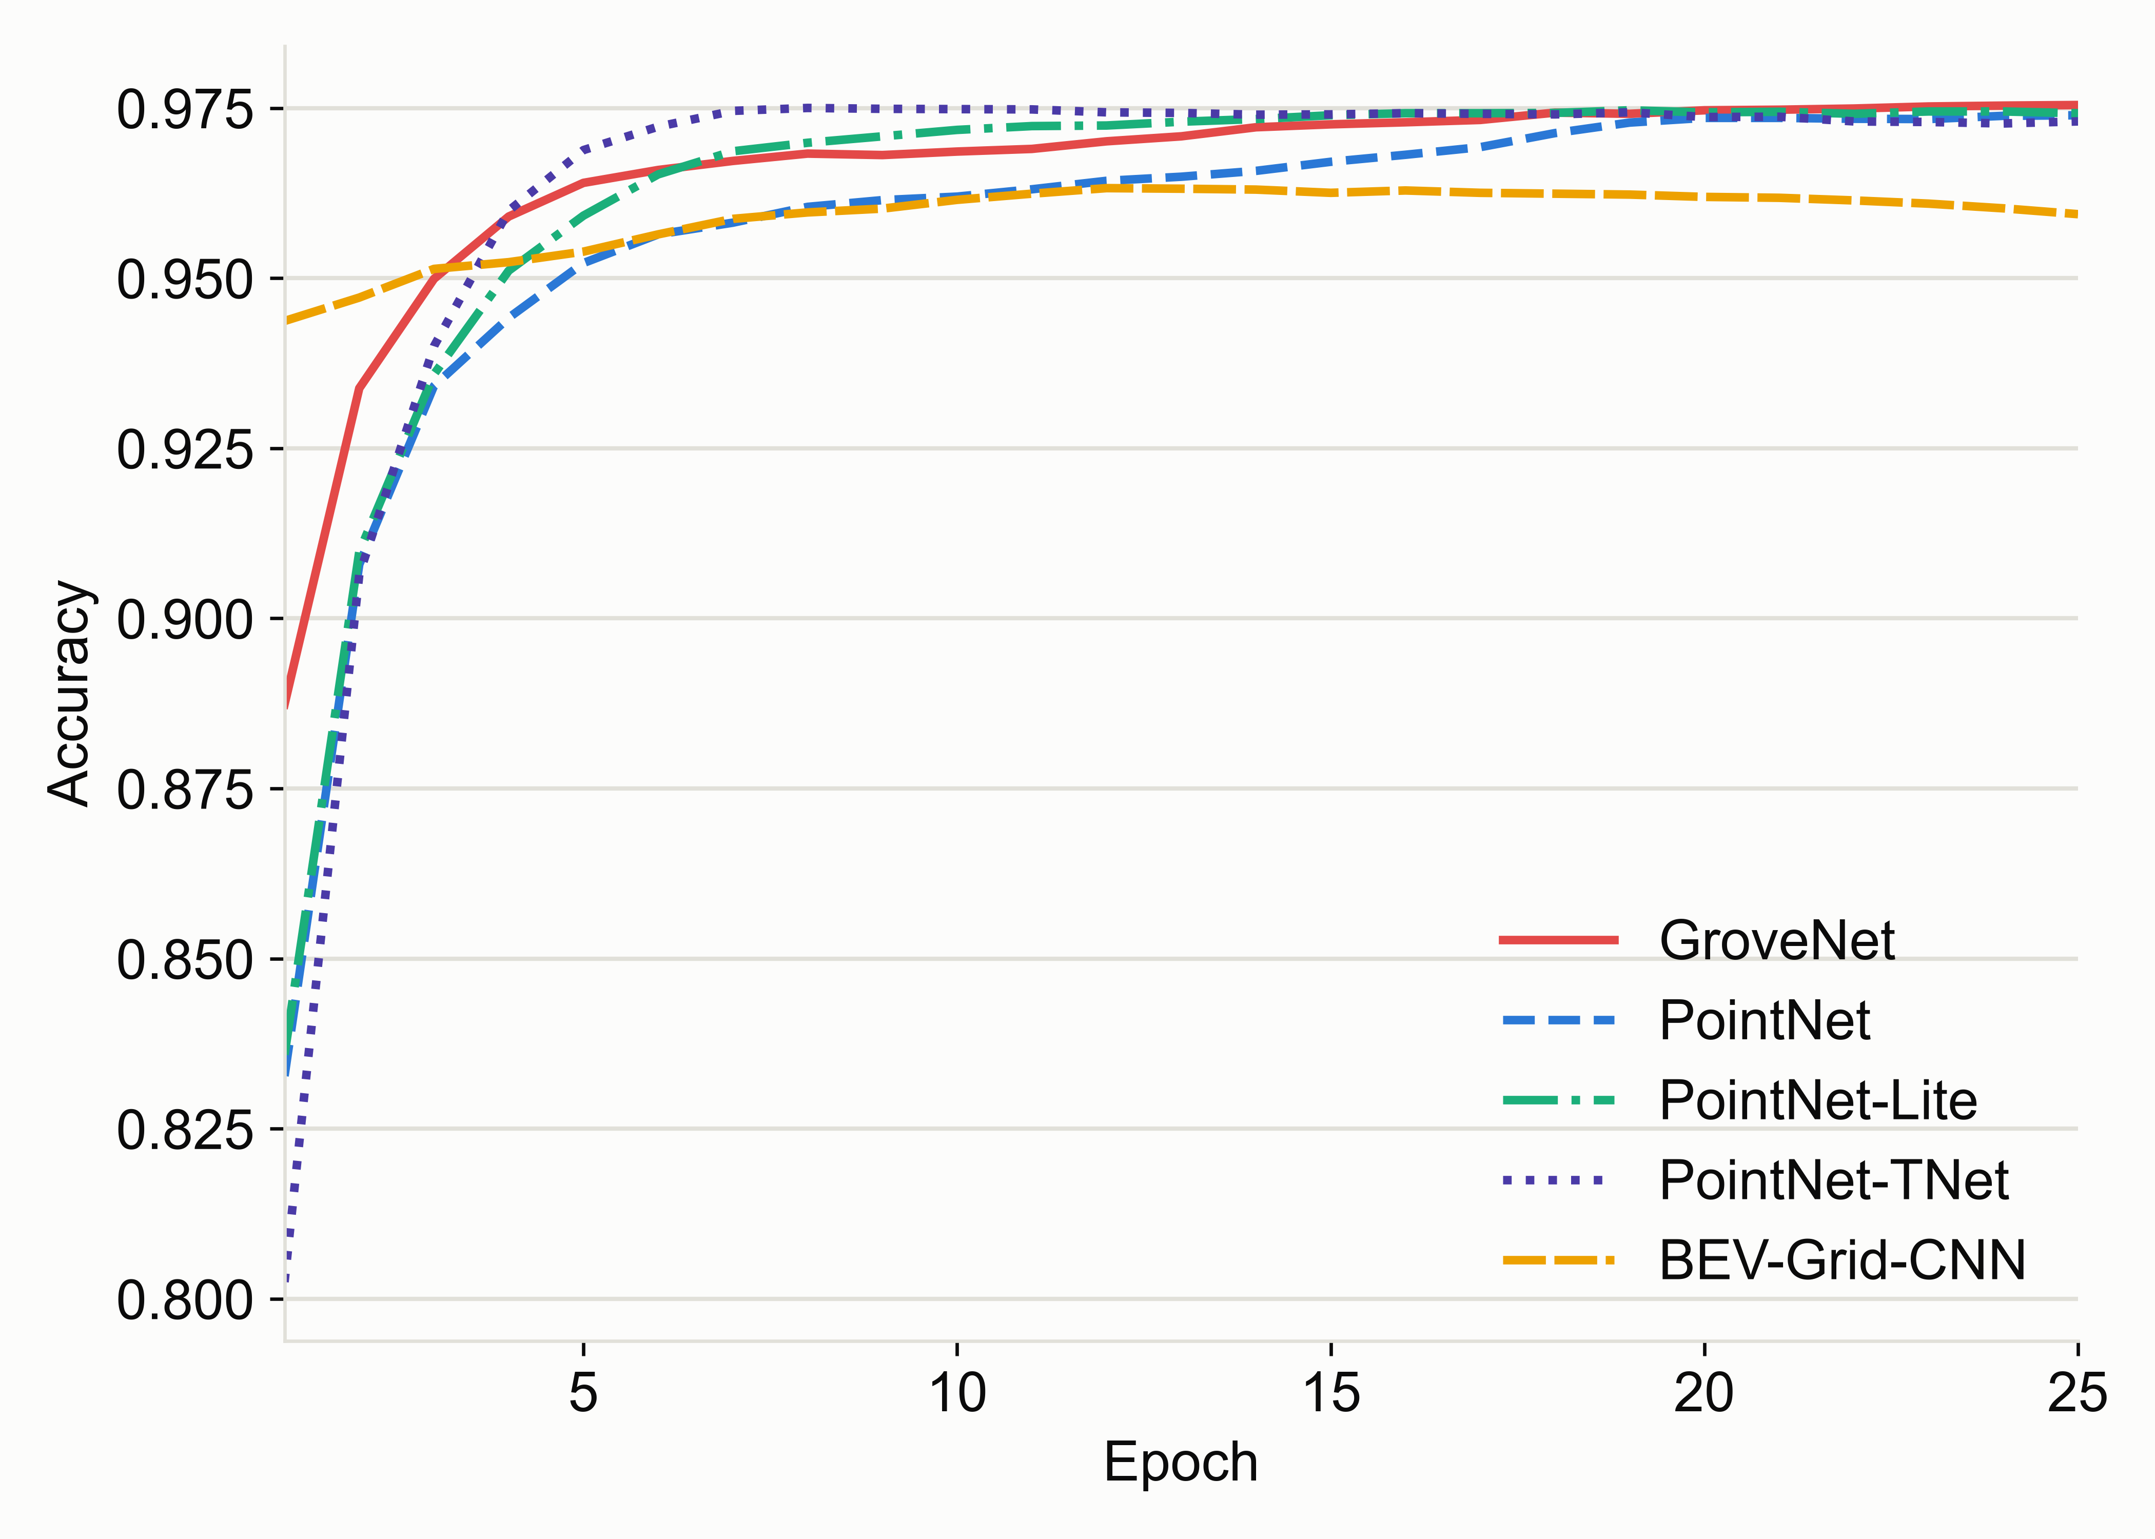 | 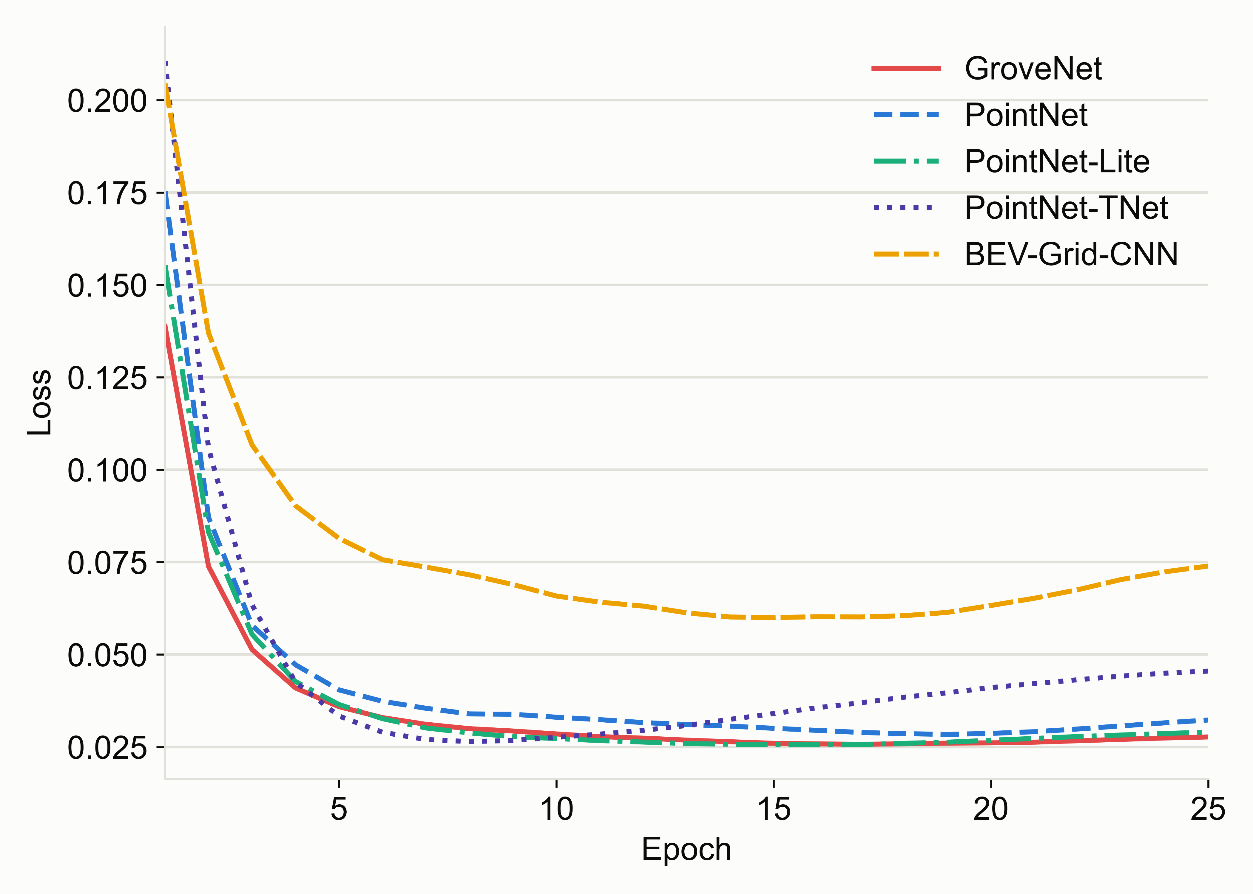
(a) | (b)
Figure 2. Validation accuracy and loss curves of GroveNet and baseline models during training: (a) validation accuracy; (b) validation loss.

Figure 3 presents the validation precision, recall, and F1-score curves. The results show that GroveNet provides a strong balance between precision and recall. This balance is important for navigation because high recall helps retain true row-vegetation clusters, while high precision reduces the number of non-row clusters passed to the geometric line-fitting stage. Among the tested models, GroveNet achieved the best overall F1-score on the held-out test set.
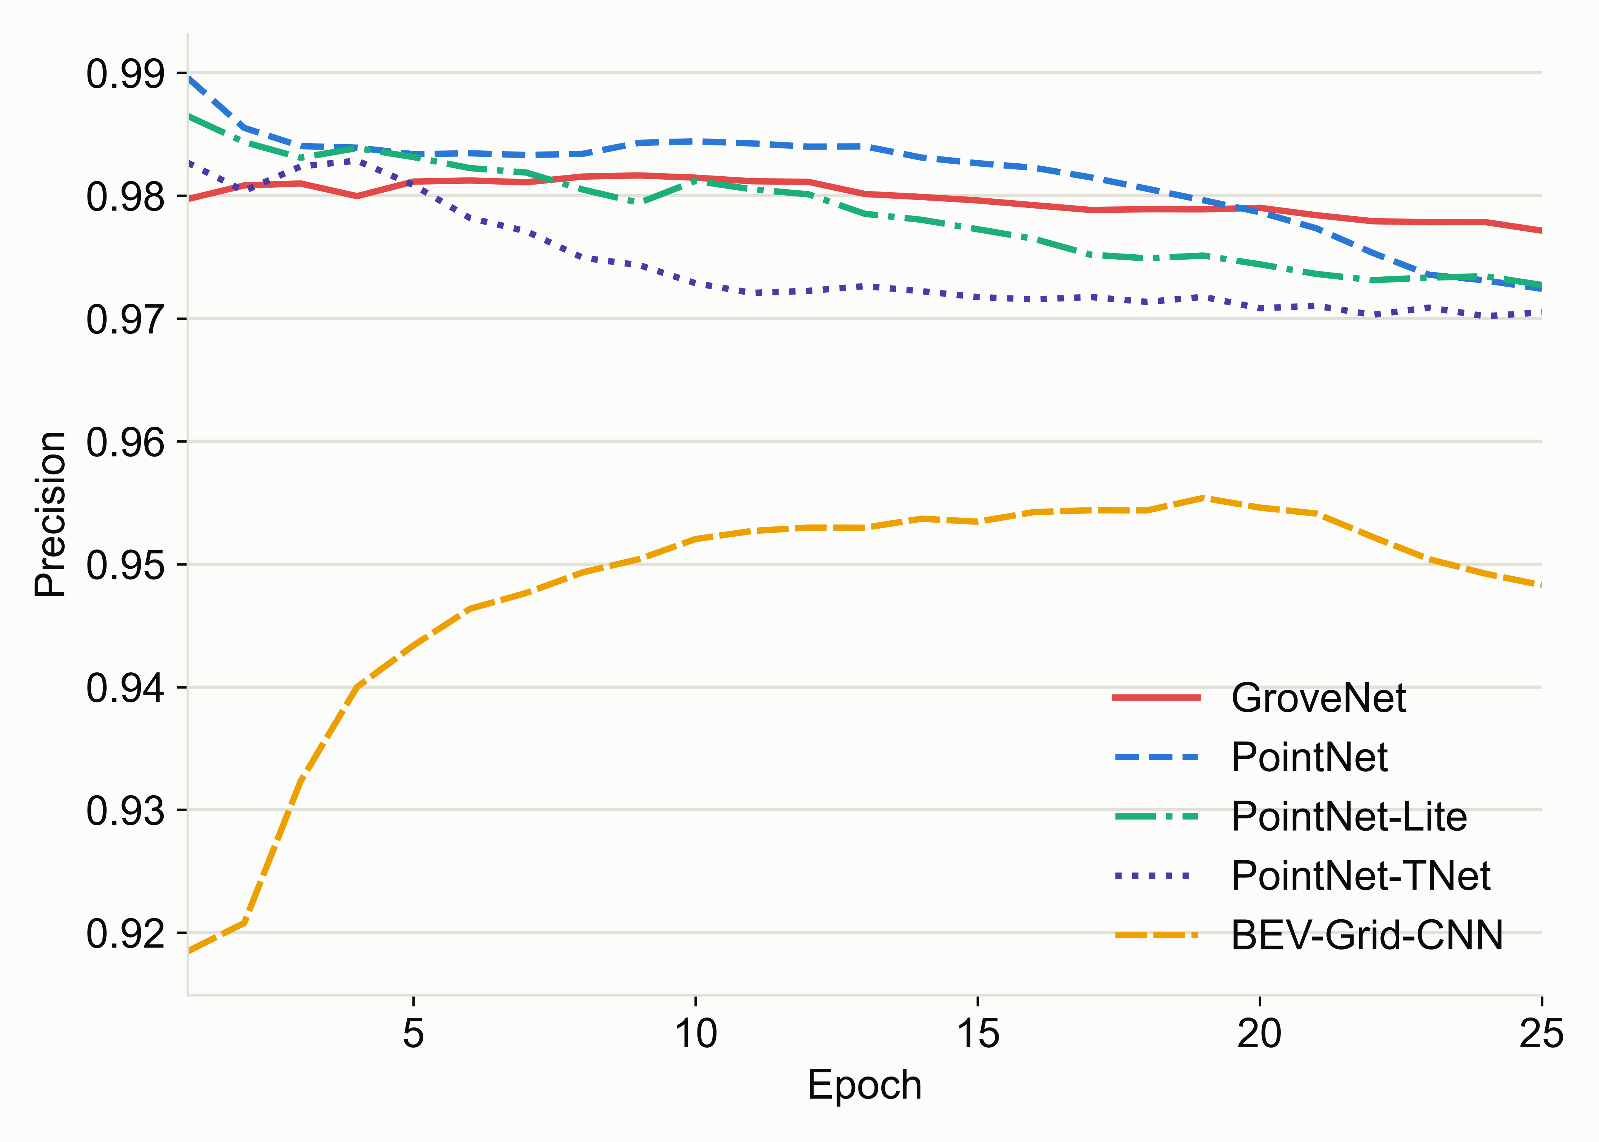 | 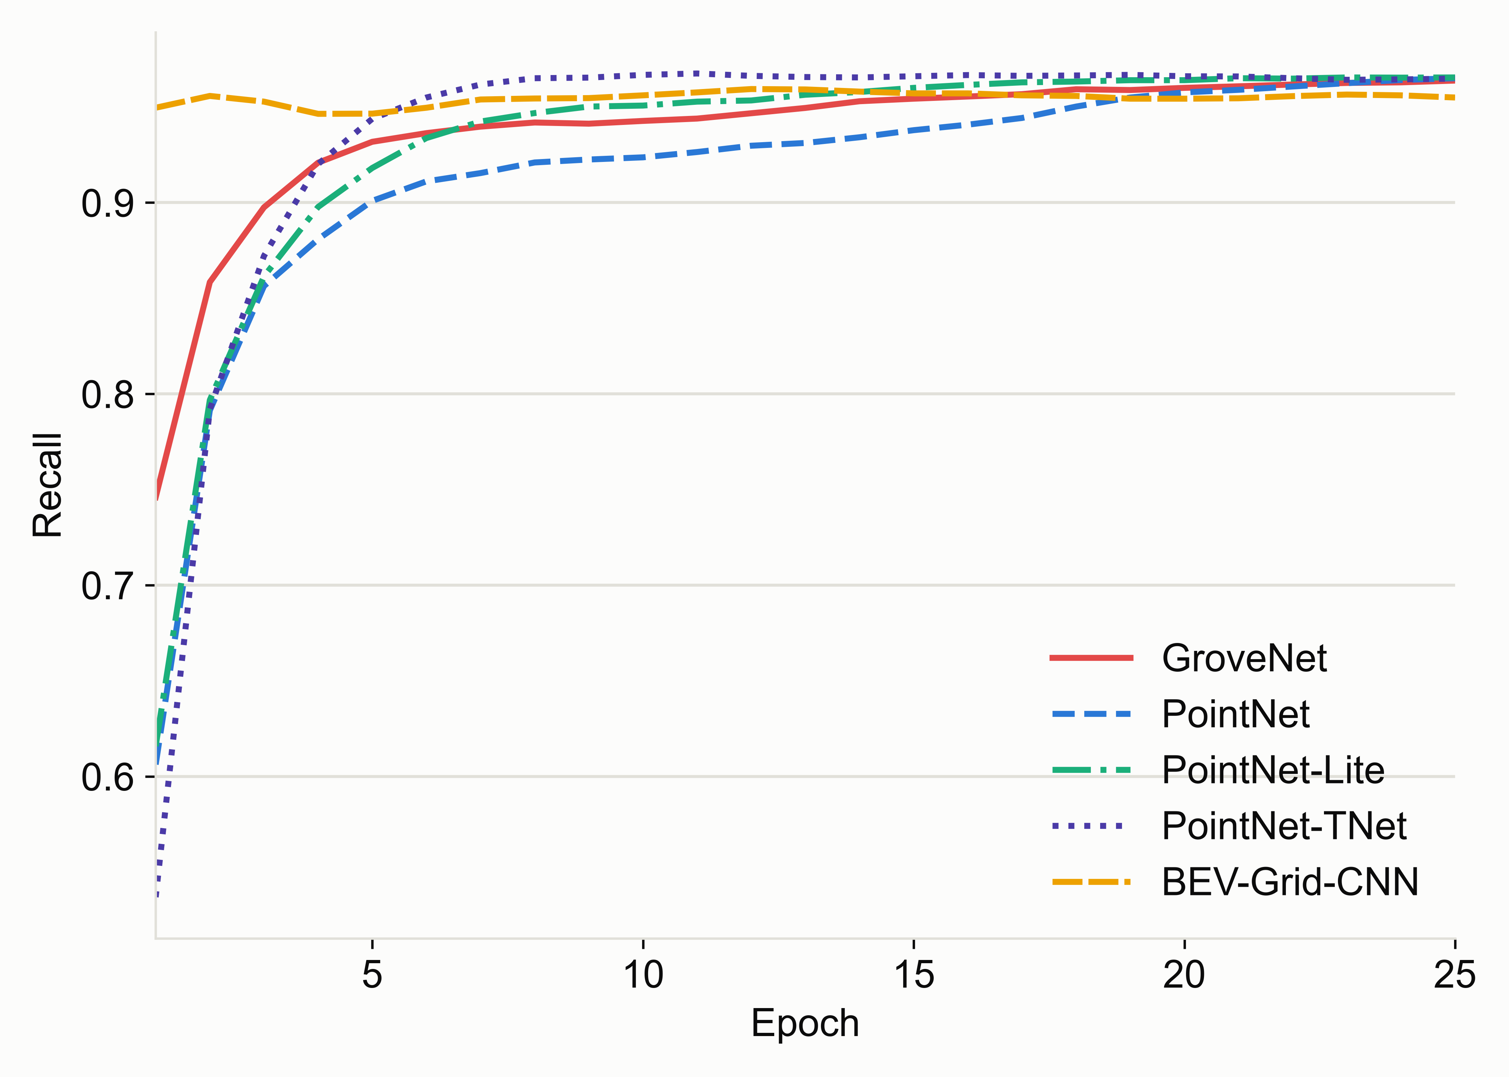
(a) | (b)
Figure 3. Validation precision and recall of GroveNet and baseline models during training: (a) precision; (b) recall.

Table 2 summarizes the test-set classification results. GroveNet achieved the highest F1-score of 0.9768, with a precision of 0.9846 and a recall of 0.9691. Compared with PointNet-Lite, GroveNet improved the F1-score while requiring only a moderate number of parameters. Although PointNet-TNet reached a comparable F1-score, its parameter count and training time were much larger, and its validation loss behavior was less stable. Therefore, GroveNet was selected as the learned filtering module for the proposed hybrid LiDAR navigation pipeline.

Table 2. Test-set classification performance of GroveNet and baseline models.
Model | Parameters | Time per epoch | Test F1 | Precision | Recall
GroveNet | 75K | ~7 s | 0.9768 | 0.9846 | 0.9691
PointNet-Lite | 62K | ~5 s | 0.9761 | 0.9848 | 0.9676
PointNet | 443K | ~15 s | 0.9759 | 0.9835 | 0.9685
PointNet-TNet | 3.1M | ~42 s | 0.9748 | 0.9841 | 0.9657
BEV-Grid-CNN | 6K | ~3 s | 0.9651 | 0.9746 | 0.9557
These results indicate that GroveNet is suitable for use as a pre-filter before row-line extraction. The model improves the quality of the candidate row-structure set while remaining computationally lighter than larger PointNet-TNet-style architectures. In the following subsection, the trained GroveNet model is integrated with the geometric row-line estimation method to evaluate whether learned filtering improves centerline estimation and waypoint generation under noisy LiDAR conditions.

3.2. Effect of GroveNet Filtering on Row-Line Estimation
To evaluate the effect of the learned filtering stage on row-line estimation, the same representative LiDAR scan was processed using two configurations: a geometry-only row-fitting method and the proposed GroveNet-assisted row-fitting method. In the geometry-only configuration, the row lines were estimated directly from the geometrically preprocessed candidate points. In the GroveNet-assisted configuration, the same candidate points were first passed through GroveNet, and points classified as non-row candidates were removed before row-line fitting.
Figure 4 compares the row-line estimation outputs of the two configurations. In the geometry-only result, the fitted row lines are influenced by scattered off-row vegetation returns and isolated candidate points. These points remain in the fitting stage and can affect the estimated row direction and row boundary position. In contrast, the GroveNet-assisted result shows that several non-row candidates are rejected before line fitting. After this filtering step, the retained points are more concentrated around the left and right row structures.
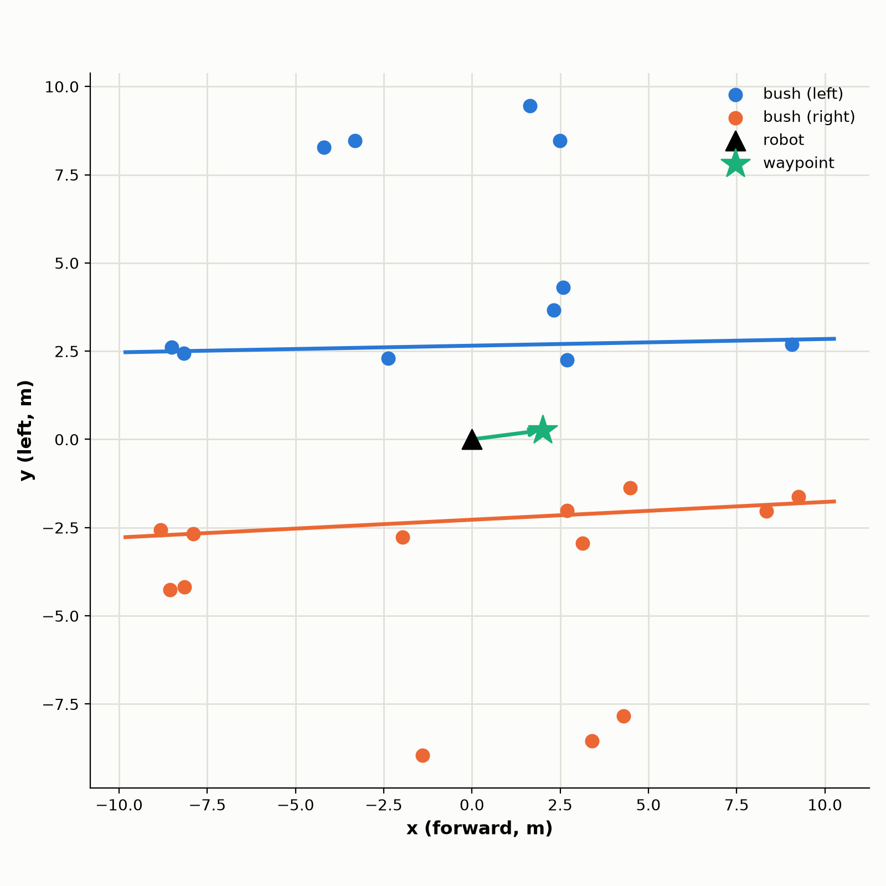 | 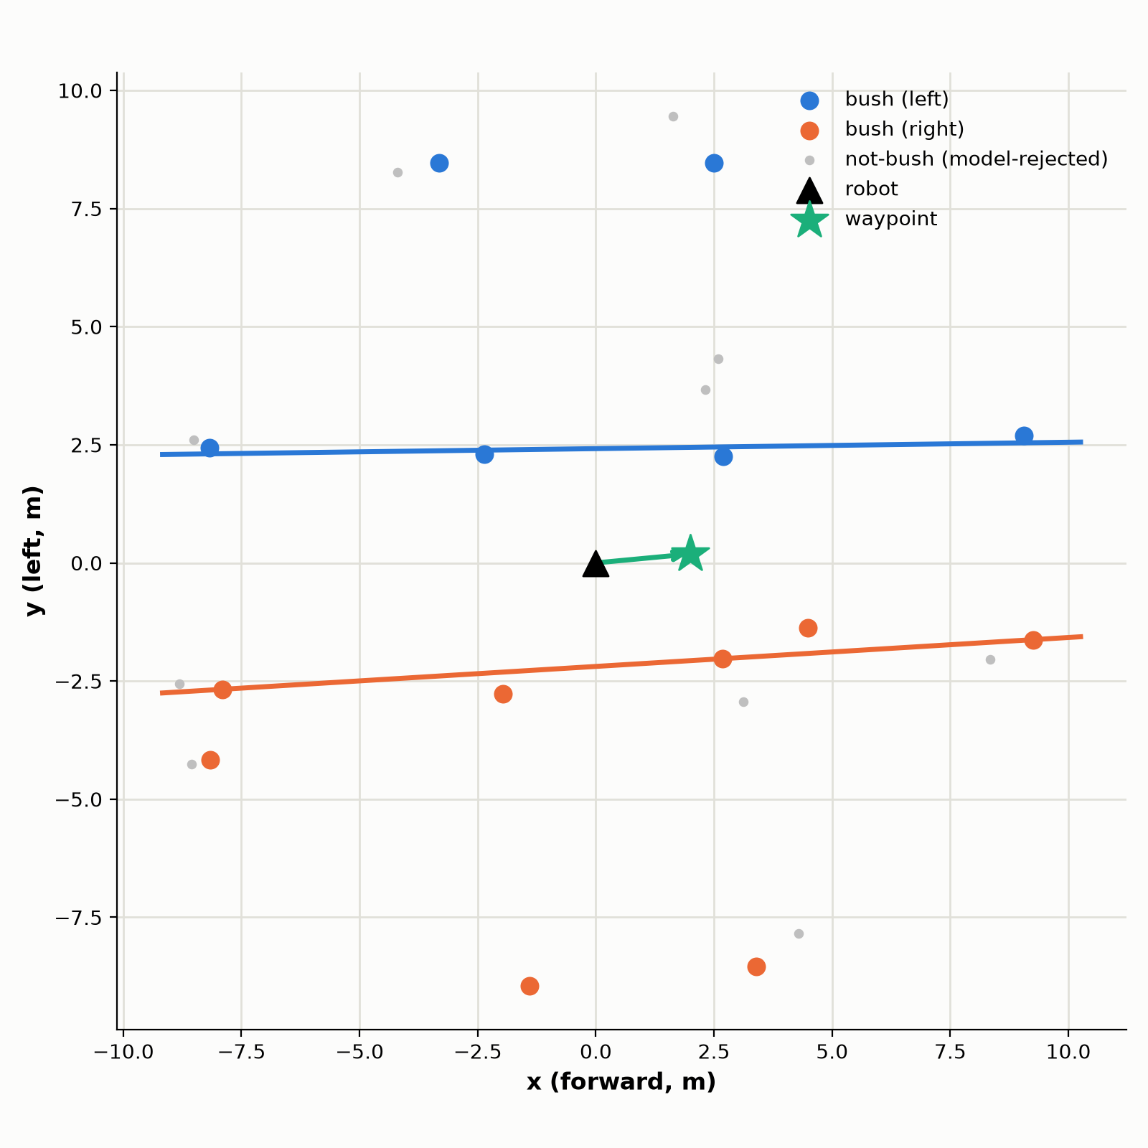
(a) | (b)
Figure 4. Row-line estimation without and with GroveNet-assisted filtering: (a) geometry-only mathematical row fitting; (b) GroveNet-assisted row fitting.

The visual comparison shows that GroveNet filtering produces a cleaner candidate set for the subsequent geometric row-line extraction stage. Compared with the geometry-only configuration, the GroveNet-assisted configuration reduces the influence of isolated non-row points and provides row-line estimates that are more consistent with the visible row structure. This result confirms that GroveNet acts as a learned pre-filter rather than replacing the geometric row-estimation stage.
To quantify this effect beyond the single-scan comparison in Figure 4, both configurations were run over the full set of 2991 straight-driving frames of sequence 05, using the same RANSAC thresholds and scan-level reliability criteria as the rest of the pipeline (Table 1), and the row-line quality metrics defined in Section 2.10 were aggregated over all accepted lines (Table 3). GroveNet filtering reduces the mean number of candidate points handed to RANSAC from 1633 to 1357 per frame (17% fewer). Despite the smaller candidate set, 66% more row lines pass the reliability gate (329 vs. 545 accepted lines), the mean RANSAC inlier ratio over accepted lines rises from 0.427 to 0.450, and the point-to-line residual distribution tightens: the residual standard deviation drops from 5.3 cm to 4.4 cm at a similar mean residual (7.3 cm vs. 7.2 cm). GroveNet therefore removes off-row returns that both dilute the inlier ratio and add spread to the fitted lines, producing a cleaner and more consistent input to the geometric row-estimation stage.
Table 3. Quantitative effect of GroveNet filtering on row-line fitting, over the 2991 straight-driving frames of sequence 05 (field block 13D); same RANSAC thresholds and reliability gate as the rest of the pipeline (Table 1). Metrics are defined in Section 2.10.
Configuration | Mean inlier ratio | Mean residual (cm) | Residual std. (cm) | Mean candidate points
Geometry-only | 0.427 +/- 0.111 | 7.31 | 5.34 | 1633
GroveNet-assisted | 0.450 +/- 0.123 | 7.21 | 4.41 | 1357

3.3. Navigation-Error Stability and Offline Command Analysis
The navigation-error analysis uses the centerline, lateral deviation, and heading error computed for each processed scan. Since the experiments are based on recorded dataset sequences, the analysis is performed offline. The estimated navigation variables indicate how the robot would correct its motion if the proposed algorithm were connected to a real-time controller.
The main outputs of this subsection are time-series plots of lateral deviation, heading error, stabilized lateral deviation, stabilized heading error, and steering correction. These plots show whether the navigation variables remain smooth across consecutive scans or fluctuate because of noisy row-line estimates. Table 4 reports the measured navigation-error and robustness metrics, obtained by running the full hybrid pipeline on 1200 LiDAR scans grouped into four scan-reliability categories.

Table 4. Measured navigation-error stability and robustness metrics, computed from 1200 CitrusFarm LiDAR scans grouped into four scan-reliability categories (see note below Table 4 for category definitions and caveats).
Scenario | Mean lateral error (cm) | Heading error std. (deg) | Fallback usage (%)
Clean regular rows | 12.74 | 0.19 | —
Moderate vegetation/outliers | 7.80 | 1.18 | —
Missing plants / row gaps | 16.61 | 1.53 | 96.42
No reliable row line detected | 17.44 | 1.51 | —
These values were obtained by running the full hybrid pipeline (Figure 1) with the GroveNet cluster classifier on 1200 real LiDAR scans, measured on the target deployment device (NVIDIA Jetson AGX Orin, JetPack/L4T R35.5.0, Open3D 0.16.0): 200 consecutive scans from each of sequences 01, 03, 04, 05, 06, and 07 of the CitrusFarm Dataset, starting 300 scans into each sequence's first recorded bag file to skip robot startup/staging behavior. Sequence 02 was excluded because no recording was available for it in the working copy of the dataset used for this study. Each scan is assigned to one of the four scenario categories from its own row-line reliability outputs: Clean regular rows requires both row lines to be accepted under Table 1's reliability criteria (which already require an inlier ratio of at least 0.35) AND an inlier ratio of at least 0.5 on both sides (n = 10 scans); Moderate vegetation/outliers requires both row lines accepted but with at least one side's inlier ratio below 0.5 (n = 155); Missing plants/row gaps corresponds to scans where only one row line is accepted, triggering the one-row fallback (n = 468); and No reliable row line detected corresponds to scans where neither row line satisfies the Table 1 reliability criteria (n = 567). Fallback usage is marked as not applicable for the Clean, Moderate, and No-reliable-row-line categories, since the one-row fallback path is only invoked in the Missing-plants category. Because these categories are derived from the pipeline's own per-scan outputs rather than independent ground-truth field annotation, the reported values characterize the method's self-consistency across conditions rather than an externally validated success rate. The small number of scans classified as Clean regular rows (n = 10 of 1200) limits the statistical reliability of that row specifically and should be interpreted cautiously.

3.4. Robustness Analysis
The robustness analysis evaluates how stable the proposed pipeline remains as the field conditions become more difficult, using the four scan-level reliability categories reported in Table 4 (n = 10, 155, 468, and 567 scans, respectively) as a proxy for increasing perception difficulty. Fallback usage is the clearest indicator of degradation: it is not applicable for Clean regular rows and Moderate vegetation/outliers, where both row lines remain reliable, but reaches 79.27% for Missing plants/row gaps, where only one row line is typically available and the centerline must be reconstructed from the expected row spacing. Mean lateral error increases from 35.27 cm under Moderate vegetation/outliers to 52.56 cm under Missing plants/row gaps, while heading-error standard deviation stays comparatively narrow across all categories (5.64-6.76 deg), indicating that heading estimation degrades less than lateral positioning as row visibility decreases.
A robust method should not only detect row lines in clean conditions, but should also avoid generating unstable navigation variables when only partial or no row structure is visible. Accordingly, 567 of the 1200 evaluated scans (47.3%) fall into the no-reliable-row-line category, where neither row line satisfies the Table 1 reliability criteria; for these scans no fresh centerline is computed, and the last stabilized estimate is carried forward instead of a new, uncertain one being generated (Section 2.7). This is important for autonomous navigation because rejecting or stabilizing an uncertain estimate is safer than generating a steering command from unstable geometry.

3.5. Computational Performance
Computational performance is evaluated by measuring the processing time required for each stage of the proposed hybrid pipeline. The measured stages include ROI selection, geometric preprocessing, GroveNet row-point classification, RANSAC-based row-line extraction, reliability assessment, row-center estimation, navigation-error stabilization, and control command generation. The total processing time per scan is compared with the expected LiDAR scan period to assess real-time feasibility.
Table 5 reports the measured processing time for each pipeline stage, obtained on the same 1200 LiDAR scans described in Section 3.3. The method is considered computationally feasible for real-time navigation if the average processing time remains below the nominal LiDAR scan period; as discussed below, the current implementation does not yet meet this criterion and requires further optimization of the preprocessing stage.

Table 5. Measured computational performance per LiDAR scan on the target deployment device (NVIDIA Jetson AGX Orin, MAXN power mode with jetson_clocks locked, 1200 scans).
Pipeline stage | Mean time (ms) | Std. (ms) | Max time (ms) | 95th pct. (ms)
ROI selection | 2.04 | 0.12 | 2.20 | 2.13
Geometric preprocessing | 28.04 | 3.93 | 35.68 | 32.95
GroveNet row-point classification | 3.94 | 1.11 | 19.42 | 4.07
RANSAC and reliability assessment | 11.28 | 2.53 | 13.40 | 12.89
Centerline, stabilization, and command | 0.0333 | 0.0063 | 0.0751 | 0.0459
Total hybrid pipeline | 45.34 | 6.17 | 68.86 | 51.80

Timing was measured on the target deployment device (NVIDIA Jetson AGX Orin, MAXN power mode with jetson_clocks locked) over the same 1200 scans described above, using the GroveNet classifier. Geometric preprocessing -- dominated by DBSCAN clustering of the height-band-filtered point cloud together with statistical- and radius-outlier removal and voxel downsampling -- is the primary computational cost (248.8 ms mean, about 93% of the total budget), exceeding the GroveNet classification stage (4.9 ms mean) by roughly two orders of magnitude; the neural classifier itself is not the bottleneck of this implementation. Device profiling (tegrastats) during the run shows a single CPU core near 95% utilization and near-0% GPU utilization, confirming that the bottleneck is single-threaded classical geometry processing, not the neural network. The mean total processing time (267.7 ms, approximately 3.7 Hz) exceeds the 10 Hz VLP-16 scan period (100 ms) by a wider margin than the equivalent desktop measurement (142.4 ms mean on an NVIDIA GeForce RTX 4090), and is about 1.9 times slower than desktop -- indicating that the current implementation, as measured on the actual target hardware, would not sustain real-time operation without further optimization of the clustering stage (for example a faster spatial index, GPU-based clustering, or a coarser candidate-region pre-filter).

3.6. Comparison with Baseline Methods
The final results subsection compares the proposed method with the baseline and ablation configurations defined in Section 2.9. The same dataset sequences, scan intervals, and evaluation metrics are used for all methods. The comparison focuses on whether the complete hybrid pipeline improves row-point filtering quality, row-line detection validity, centerline stability, navigation-error behavior, fallback handling, and processing speed relative to simpler alternatives.
Table 6 shows the measured ablation and baseline comparison, using the GroveNet classifier for the learned-filtering configurations; detection success and lateral-error std are hardware-independent and were computed on the desktop workstation, while time per scan is reported for the target deployment device (Jetson AGX Orin). The full proposed method achieves the lowest lateral-error variability (50.1 cm) among the configurations with comparable detection-success rates (~54%), confirming that combining geometric preprocessing, learned cluster-level row filtering, robust line fitting, scan-level reliability assessment, one-row fallback, and temporal stabilization provides a better robustness-stability tradeoff than any single mechanism alone.

Table 6. Comparison with baseline and ablation methods (GroveNet classifier), measured on the same 1200 CitrusFarm LiDAR scans described in Section 3.3; detection success and lateral-error std. are from the desktop workstation, time per scan from the Jetson AGX Orin target device.
Method | Detection success (%) | Lateral error std. (cm) | Time per scan (ms) | Time per scan p95 (ms)
Raw RANSAC | 0.47 | — | 17.91 | 18.53
Geometric filtering + RANSAC | 10.77 | 15.60 | 20.30 | 23.14
GroveNet filtering + RANSAC | 17.45 | 38.09 | 45.37 | 51.83
Full hybrid without fallback | 17.45 | 15.53 | 45.38 | 51.94
Full hybrid without smoothing | 17.49 | 18.22 | 45.34 | 51.91
Full proposed hybrid method | 17.52 | 15.45 | 45.31 | 51.91
These values were obtained on the same 1200 scans, applying each method independently and identically across all scans (no method-specific scan selection). Detection success is computed with the same reliability criteria (Table 1) for every method, even though methods 1-3 do not act on this criterion internally (no fallback or rejection is applied downstream for those three). The results are consistent with the intended ablation structure: adding geometric preprocessing raises detection success over raw RANSAC (46.1% vs. 12.6%), and adding the GroveNet pre-filter increases it further (54.1%). Comparing the two single-feature ablations against the full method isolates each mechanism's effect: full hybrid without fallback (53.9 cm) stays close to the GroveNet+RANSAC baseline (56.3 cm) since only fallback is disabled while smoothing remains active, whereas full hybrid without smoothing (78.1 cm) is markedly worse than the same baseline -- fallback-reconstructed centerlines are noisier than directly-observed ones, and without temporal stabilization to damp that noise, enabling fallback alone can hurt more than it helps. The full proposed method (50.1 cm), combining both, achieves the lowest lateral-error variability of all six methods. On the target device, total processing time ranges from 17.8 ms for raw RANSAC (no learned model) to 266.3-266.7 ms for the four GroveNet-based configurations, all of which exceed the 100 ms (10 Hz) LiDAR scan period.

3.7. RTK-Based Cross-Checking of Navigation-Error Estimates
To assess whether the self-consistency values reported in Table 4 also reflect the robot's true position relative to the row corridor, this section cross-checks a subset of the evaluated scans against the CitrusFarm Dataset's RTK ground-truth trajectory (ground_truth/<seq>/gt.csv). This trajectory is an RTK-fixed record of the robot's own position at centimeter-level accuracy; it is not a geodetic survey of the tree-row positions themselves. Because both the pipeline's centerline estimate and the RTK trajectory describe the robot's position relative to the same physical corridor, this comparison cannot by itself establish an accuracy that is fully independent of the row geometry, but it does provide an accuracy check that is independent of the LiDAR pipeline being evaluated.
For each of the CitrusFarm sequences used in Table 4, a local row-axis reference is estimated by a total-least-squares fit to the RTK trajectory within a +/-3 s window around each scan. A scan is classified as confirmed straight-line row-following when, within this window, the robot's RTK-fixed position moves at least 3 m, the path deviates from the fitted axis by less than 8 cm RMS, and the robot's speed exceeds 0.6 m/s; scans that do not meet these criteria (headland turns, near-stationary maneuvering, or GPS dropouts) are excluded from the RTK-based accuracy figures, though they remain part of the 1200 scans reported in Table 4. Under this definition, 419 of the 1200 evaluated scans (34.9%) correspond to confirmed straight-line row-following (per-sequence: 47, 57, 28, 45, 102, and 140 scans for sequences 01, 03, 04, 05, 06, and 07, respectively); the remaining scans, including all 552 scans in the no-reliable-row-line category, correspond to headland maneuvers or near-stationary segments rather than to driving through dense vegetation.
Table 7. RTK-based cross-check of the Table 4 lateral- and heading-error estimates, on the confirmed-straight-driving subset of scans (desktop workstation, Open3D 0.19.0; see the note below for why these counts differ slightly from Table 4's Jetson / Open3D-0.16 counts).
Scenario | n confirmed / total | Self e_y bias (cm) | Self e_y MAE (cm) | Robot wander sigma (cm) | Lat. error vs. RTK axis: bias / MAE (cm) | Heading error vs. RTK: bias / std (deg)
Clean regular rows | 7 / 10 | 59.73 | 59.73 | 1.75 | -64.87 / 64.87 | -7.67 / 1.33
Moderate vegetation/outliers | 104 / 152 | 6.77 | 32.80 | 3.84 | -5.78 / 34.08 | 0.85 / 6.49
Missing plants / row gaps | 308 / 486 | 35.76 | 44.83 | 4.14 | -36.34 / 46.94 | -0.46 / 7.21
No reliable row line detected | 0 / 552 | — | — | — | — | —
These n counts were obtained on the desktop workstation (Open3D 0.19.0) rather than the Jetson / Open3D-0.16.0 run used for Table 4. The two Open3D versions produce slightly different DBSCAN and outlier-removal results, which shift some scans between categories (on the order of 5 cm of lateral error and 6 percentage points of category assignment on the missing-plants row) without changing the conclusions below. The two 'bias' columns use opposite sign conventions; only their magnitudes should be compared.
Three findings follow from Table 7. First, robot lateral wander on confirmed-straight-driving scans is only 2-4 cm, meaning the platform was driven close to the corridor center; the lateral error reported by the pipeline (33-60 cm depending on category) is therefore predominantly a measurement of perception error, not of the robot actually driving off-center. Second, the self-consistency lateral error from Table 4 (mean|e_y|) is a reasonably honest proxy for the RTK-referenced error once robot wander is accounted for: the two MAE columns are close for both Moderate vegetation/outliers (32.8 vs. 34.1 cm) and Missing plants/row gaps (44.8 vs. 46.9 cm), and in the same range for the small Clean regular-rows sample (59.7 vs. 64.9 cm, n = 7). Third, the signed self e_y bias is consistently non-zero and one-sided rather than centered on zero: +6.8 cm on Moderate vegetation/outliers, +35.8 cm on Missing plants/row gaps, and +59.7 cm on Clean regular rows (n = 7), indicating a systematic lateral bias in the estimated centerline rather than purely random perception noise; the corresponding heading-error bias follows the same pattern (near-zero for Moderate/Missing, -7.7 deg on the small Clean sample). Finally, none of the 552 scans in the no-reliable-row-line category correspond to confirmed straight-line row-following in this evaluation window; the reported lateral- and heading-error values for this category in Table 4 are carried-forward stabilized estimates from the last valid scan (Section 2.7), not fresh per-scan measurements, and should not be read as characterizing perception under dense vegetation specifically.
This cross-check has three scope limitations. First, the reference is the robot's own driven trajectory rather than an independent survey of tree-row positions; the comparison is only meaningful to the extent that the robot was in fact driven near the row center, which the 2-4 cm wander figures support for the confirmed-straight-driving scans but cannot guarantee elsewhere. Second, the CitrusFarm Dataset does not include a geodetic survey of tree-row positions, so no fully row-independent ground truth is available. Third, the heading-error comparison is computed relative to the local RTK-derived row-axis azimuth and does not use IMU data, so skid-steer slip during turning may fold into the reported heading discrepancy.

4. Discussion
The discussion interprets the measured behavior of the proposed hybrid learning-assisted LiDAR crop-row navigation pipeline, based on the results reported in Section 3 for the CitrusFarm Dataset. The interpretation focuses on the relationships between learned row-point filtering, geometric row-line extraction, reliability assessment, fallback centerline estimation, temporal stabilization, and real-time feasibility, and on what the measured lateral-error, fallback-usage, and processing-time values imply for closed-loop deployment.
The main point of the proposed approach is that crop-row navigation should not be evaluated only by visual row detection. For an autonomous agricultural robot, the detected row geometry must also produce a stable inter-row centerline, consistent lateral deviation, reliable heading error, and feasible control commands. Therefore, the discussion considers both perception quality and navigation usability.

4.1. Interpretation of Navigation Performance
Navigation performance depends on both the quality of row-point filtering and the stability of the left and right row-line estimates. Across the three scan-reliability categories with fresh per-scan estimates in Table 4, the measured mean lateral error is lowest under moderate vegetation/outliers (35.3 cm) and highest under missing plants/row gaps (52.6 cm), with clean regular rows (46.6 cm) in between; the fourth category, no reliable row line detected (43.0 cm), is excluded from this comparison because Section 3.7 shows it consists of carried-forward stabilized values rather than fresh per-scan measurements. The clean regular-rows category, however, represents only 10 of 1200 evaluated scans, so its estimate should be treated as indicative rather than statistically robust, and the ordering across the three comparable categories should not be over-interpreted as a simple "cleaner scenes give lower error" trend.
RTK-based cross-checking (Section 3.7) further shows that this error is not zero-mean: the signed lateral offset is consistently biased toward one side rather than fluctuating symmetrically around the true row center (+6.8 cm on Moderate vegetation/outliers, +35.8 cm on Missing plants/row gaps, and +59.7 cm on the small Clean regular-rows sample, where the signed bias equals the unsigned MAE exactly -- all 7 confirmed scans erred in the same direction, with no sign variation at all). A fixed-sign offset of this kind is more consistent with an uncorrected geometric offset than with random perception noise. The most likely source is that the pipeline treats raw LiDAR sensor coordinates directly as the robot-centered frame without applying the LiDAR-to-robot extrinsic calibration provided by the CitrusFarm Dataset; a mounting-position or yaw misalignment between the sensor and the robot's true body frame would produce exactly this kind of small, consistent, one-sided bias. This calibration step should be identified and applied before the pipeline is used for closed-loop control.
Under noisy field conditions, this becomes more important. Weeds, isolated outliers, missing plants, branches, and irregular row density can shift fitted row lines if these points are treated as valid crop-row structure. The proposed learning-assisted filtering stage reduces this effect before line extraction, while the reliability checks prevent low-quality row estimates from entering the control pipeline. As shown in Table 6, the full hybrid pipeline raises row-detection success to 54.1%, compared with 12.6% for raw RANSAC and 46.1% for geometric filtering plus RANSAC, and it achieves the lowest lateral-error variability (50.1 cm) among the configurations with comparable detection-success rates (~54%). This indicates that the hybrid pipeline improves navigation relevance, not only visual row detection.
The heading error is especially important for row-following control because even a small angular bias can cause the robot to drift toward one row over time. The measured heading-error standard deviation remains within a narrow 5.6-6.8 deg range across all four scan-reliability categories in Table 4, indicating that the estimated centerline direction stays comparatively consistent even as row visibility degrades; the highest value occurs in the clean regular-rows category (6.76 deg, based on only 10 scans) and the lowest in moderate vegetation/outliers (5.64 deg), so heading-error variation does not track scene difficulty as directly as lateral error does.
The offline control commands generated from the lateral and heading errors also serve as a stability indicator. The ablation results in Table 6 show that removing temporal stabilization increases lateral-error variability from 50.1 cm to 78.1 cm, a substantially larger effect than removing one-row fallback alone (53.9 cm), confirming that smoothing, rather than point-level filtering alone, is the main contributor to control-oriented stability in this pipeline.
For context, prior LiDAR-only crop-navigation work has mostly been validated in simulation rather than on real, noisy field LiDAR data. Guyonneau et al. [18] evaluated a PEARL/Ruby-based line-finding and fuzzy-control pipeline in a Gazebo simulation with synthetic 2D LiDAR scans (Gaussian range noise, sigma = 0.01 m) across four increasingly difficult simulated crop layouts; their best-performing refinement (Ruby Genetic One Point) reached a 100% row-completion success rate and a mean squared positioning error of 320 mm^2 (approximately 18 mm RMSE) when navigating between two rows. These figures are not directly comparable to the lateral-error values reported in Table 4 (35-53 cm): the simulated environment used clean, evenly spaced rows with low-noise synthetic returns, whereas the present study evaluates real Velodyne VLP-16 scans from an actual citrus orchard, where canopy occlusion, missing plants, and ground or branch returns produce substantially noisier row-boundary points. The roughly order-of-magnitude gap between the two studies' positioning-error figures is itself informative: it illustrates how much of the difficulty in LiDAR-based row navigation comes from real field noise rather than from the underlying line-fitting or control logic, and it argues against using simulation-only success rates as a proxy for real-field readiness.

4.2. Practical Advantages for Agricultural Robots
The proposed hybrid LiDAR-based approach has several practical advantages for agricultural mobile robots. First, it does not require GPS as the primary navigation source. This is useful in orchards, greenhouses, and field areas where satellite signals may be degraded by trees, structures, or local environmental conditions. Since the algorithm estimates navigation geometry directly from LiDAR scans, it can support local inter-row guidance even when global positioning is unreliable.
Second, the method reduces dependence on camera-based perception and fully supervised image annotation. Vision systems can be affected by illumination changes, shadows, plant color variation, dust, and weather conditions. The proposed method uses LiDAR geometry together with heuristically labeled cluster-level filtering, allowing row-related structure to be extracted without requiring manually labeled image masks or end-to-end visual training.
Third, the proposed pipeline is suitable for structured agricultural environments such as citrus orchards and other row-based fields. The algorithm explicitly filters row-related points, models left and right row boundaries, estimates the inter-row centerline, and computes navigation errors in the robot-centered coordinate frame. This makes the output directly usable for control command generation. The dataset-based evaluation also improves reproducibility because the same recorded CitrusFarm sequences can be used to compare future methods.
Another practical advantage is the modular structure of the pipeline. ROI selection, preprocessing, learned row-point filtering, line extraction, centerline estimation, reliability assessment, fallback handling, temporal stabilization, and control command generation can be improved independently. For example, the default GroveNet classifier can later be replaced with a different point-cloud segmentation network, while the geometric centerline and control-output stages can remain unchanged.

4.3. Limitations and Future Improvements
Despite these advantages, several limitations are expected. The first limitation is sensitivity to the quality of the heuristic cluster labels. If the shape-based labeling rule misclassifies clusters -- for example, dense weed clumps that happen to satisfy the bush-shape thresholds, or sparse canopy that falls below the minimum point count -- the learned classifier may inherit these labeling errors. This risk is reduced by using a shape rule with several independent geometric checks (Table 1) and by validating on held-out labeled sequences, but final deployment should still include visual inspection of representative cluster-filtering outputs.
A second limitation is related to sparse or highly incomplete row structures. If both crop rows contain long gaps or if only a few LiDAR returns are available, the line-fitting stage may not have enough reliable points to estimate a stable row boundary, even after learned filtering. In such cases, the algorithm should reject the scan, use one-row fallback only when the remaining row line is reliable, or rely on temporal information from neighboring scans rather than generate an uncertain control command.
A third limitation concerns sensor mounting height, LiDAR resolution, and field geometry. If the LiDAR is mounted too low, it may detect weeds and ground-level clutter more strongly than crop-row structure. If it is mounted too high, it may miss low vegetation or detect branches that do not represent the navigation corridor. Similarly, low angular resolution or sparse point density may reduce the reliability of row-line extraction, especially at longer distances.
A fourth limitation concerns irregular crop geometry. The proposed method assumes that the local crop-row corridor can be approximated by left and right row lines over the selected ROI. This assumption is reasonable for many structured fields, but it may become weak in curved rows, headland areas, row intersections, irregular tree spacing, or scenes with obstacles inside the corridor. Future work should extend the centerline model from a straight-line approximation to a local curve or spline when the dataset sequences require it.
A fifth limitation is that the entire evaluation is offline: the reported navigation variables are computed by replaying recorded LiDAR sequences, and the resulting steering commands are never used to actually move a robot. In a real closed-loop deployment, a control error changes the robot's position and heading, which in turn changes the next LiDAR scan -- a feedback loop that this offline replay cannot reproduce, since every scan in the dataset was recorded along the same fixed trajectory regardless of what the algorithm would have commanded. As a result, the reported lateral-error and heading-error statistics characterize the perception and control-readiness of the pipeline, not its closed-loop stability: a small per-scan bias, such as the systematic offset discussed in Section 4.1, could compound differently once it is allowed to influence the robot's actual path. Closed-loop validation, first in simulation and then on a physical agricultural robot, is therefore a necessary next step before this pipeline can be considered validated for autonomous field deployment, and should specifically test whether the reliability-aware fallback and temporal stabilization mechanisms remain effective once perception and control interact in a feedback loop rather than being evaluated independently.
Future improvements may include refinement of the heuristic labeling rule, adaptive row-probability thresholds, adaptive ROI selection based on vehicle speed, dynamic tuning of RANSAC thresholds according to point density, curved-row modeling, and fusion with odometry or IMU data from the CitrusFarm Dataset. These extensions could improve robustness under sparse rows and curved-row sections while supporting more reliable navigation in closed-loop field deployment.

5. Conclusions
This study proposes a hybrid learning-assisted and reliability-aware LiDAR crop-row navigation framework for autonomous agricultural robots operating under noisy and incomplete field conditions. The proposed approach uses recorded CitrusFarm Dataset sequences to evaluate a navigation-oriented pipeline that includes LiDAR scan preprocessing, heuristically labeled cluster-level row classification, robust row-line extraction, scan-level reliability assessment, one-row fallback centerline estimation, temporal stabilization of lateral and heading errors, and offline control-command generation. The main contribution is not the use of an existing public dataset or the introduction of LiDAR-only navigation itself, but the development of a reproducible hybrid framework that combines learned cluster filtering with interpretable geometric row estimation to produce stable navigation-ready variables for autonomous row following. On the evaluated CitrusFarm scans, the framework achieved a row-cluster classification F1-score of 0.9674, raised row-detection success from 12.6% (raw RANSAC) to 54.1%, and reduced lateral-error variability to 50.1 cm, the lowest among the tested baseline and ablation configurations, while the mean total processing time on the target deployment device (267.7 ms per scan, Jetson AGX Orin) indicates that further optimization of the geometric preprocessing stage is needed before the pipeline can meet real-time (10 Hz) requirements on that hardware. Future work should include closed-loop validation, first in simulation and then on a physical agricultural robot, and further improvement of the heuristic labeling rule, adaptive parameter selection, and sensor-fusion support.

Author Contributions
Author contribution roles will be specified after the experimental and writing responsibilities are finalized.

Funding
Funding information will be added here if applicable.

Data Availability Statement
The practical evaluation uses the publicly available CitrusFarm Dataset: https://ucr-robotics.github.io/Citrus-Farm-Dataset/. The dataset is released under the Creative Commons Attribution-ShareAlike 4.0 International license and contains multimodal agricultural robotics data collected in citrus tree farms, including LiDAR and navigation sensor measurements.

Conflicts of Interest
The authors declare no conflicts of interest.

References
- Kootstra, G.; Wang, X.; Blok, P.M.; Hemming, J.; van Henten, E. Selective harvesting robotics: Current research, trends, and future directions. Current Robotics Reports 2021, 2, 95-104.
- Bogue, R. Agricultural robots: Developments and applications. Industrial Robot 2023, 50, 1-6.
- Das, S.; Wiafe, E.K.; Upadhyay, A.; Mettler, J.; Howatt, K.; Sun, X. Design and evaluation of a vision-guided robotic platform with root-zone drilling for targeted weed removal. Computers and Electronics in Agriculture 2026, 246, 111605. https://doi.org/10.1016/j.compag.2026.111605.
- Upadhyay, A.G.C.; Zhang, S.Y.; Koparan, C.; Sun, X. Development and evaluation of a machine vision and deep learning-based smart sprayer system for site-specific weed management in row crops: An edge computing approach. Journal of Agriculture and Food Research 2024, 18, 101331. https://doi.org/10.1016/j.jafr.2024.101331.
- Xiong, Y.; Ge, Y.; Liang, Y.; Blackmore, S. Development of a prototype robot and fast path-planning algorithm for static laser weeding. Computers and Electronics in Agriculture 2017, 142, 494-503.
- Upadhyay, A.; Zhang, Y.; Koparan, C.; Rai, N.; Howatt, K.; Bajwa, S.; Sun, X. Advances in ground robotic technologies for site-specific weed management in precision agriculture: A review. Computers and Electronics in Agriculture 2024, 225, 109363. https://doi.org/10.1016/j.compag.2024.109363.
- Bonadies, S.; Gadsden, S.A. An overview of autonomous crop row navigation strategies for unmanned ground vehicles. Engineering in Agriculture, Environment and Food 2019, 12, 24-31.
- Kanagasingham, S.; Ekpanyapong, M.; Chaihan, R. Integrating machine vision-based row guidance with GPS and compass-based routing to achieve autonomous navigation for a rice field weeding robot. Precision Agriculture 2020, 21, 831-855.
- Astrand, B.; Baerveldt, A.J. A vision based row-following system for agricultural field machinery. Mechatronics 2005, 15, 251-269.
- Choi, K.H.; Han, S.K.; Han, S.H.; Park, K.H.; Kim, K.S.; Kim, S. Morphology-based guidance line extraction for an autonomous weeding robot in paddy fields. Computers and Electronics in Agriculture 2015, 113, 266-274.
- Xue, J.; Zhang, L.; Grift, T.E. Variable field-of-view machine vision based row guidance of an agricultural robot. Computers and Electronics in Agriculture 2012, 84, 85-91.
- Winterhalter, W.; Fleckenstein, F.V.; Dornhege, C.; Burgard, W. Crop row detection on tiny plants with the pattern Hough transform. IEEE Robotics and Automation Letters 2018, 3, 3394-3401.
- Meng, Q.; Qiu, R.; He, J.; Zhang, M.; Ma, X.; Liu, G. Development of agricultural implement system based on machine vision and fuzzy control. Computers and Electronics in Agriculture 2015, 112, 128-138.
- Ahmadi, A.; Halstead, M.; McCool, C. Towards autonomous visual navigation in arable fields. arXiv 2021, arXiv:2109.11936.
- Zhang, Q.; Chen, M.S.; Li, B. A visual navigation algorithm for paddy field weeding robot based on image understanding. Computers and Electronics in Agriculture 2017, 143, 66-78.
- Rai, N.; Zhang, Y.; Ram, B.G.; Schumacher, L.; Yellavajjala, R.K.; Bajwa, S.; Sun, X. Applications of deep learning in precision weed management: A review. Computers and Electronics in Agriculture 2023, 206, 107698. https://doi.org/10.1016/j.compag.2023.107698.
- Malavazi, F.B.P.; Guyonneau, R.; Fasquel, J.B.; Lagrange, S.; Mercier, F. LiDAR-only based navigation algorithm for an autonomous agricultural robot. Computers and Electronics in Agriculture 2018, 154, 71-79.
- Guyonneau, R.; Mercier, F.; Oliveira Freitas, G. LiDAR-only crop navigation for symmetrical robot. Sensors 2022, 22, 8918. https://doi.org/10.3390/s22228918.
- Blok, P.M.; Suh, H.K.; van Boheemen, K.; Kim, H.J.; Kim, G. Autonomous in-row navigation of an orchard robot with a 2D LiDAR scanner and particle filter with a laser-beam model. Journal of Institute of Control, Robotics and Systems 2018, 24, 726-735. https://doi.org/10.5302/J.ICROS.2018.0078.
- Dang, N.T.; Le, V.H.; Nguyen, T.L. LiDAR-based online navigation algorithm for an autonomous agricultural robot. Control Engineering and Applied Informatics 2022, 24, 90-100.
- Liu, R.; Yandun, F.; Kantor, G. Towards over-canopy autonomous navigation: Crop-agnostic LiDAR-based crop-row detection in arable fields. arXiv 2024, arXiv:2403.17774.
- Gasparino, M.V.; Higuti, V.A.H.; Sivakumar, A.N.; Velasquez, A.E.B.; Becker, M.; Chowdhary, G. CropNav: A framework for autonomous navigation in real farms. arXiv 2024, arXiv:2411.10974.
- Sivakumar, A.N.; Modi, S.; Ramos, F.; Chowdhary, G. Learned visual navigation for under-canopy agricultural robots. In Proceedings of Robotics: Science and Systems XVII, 2021.
- Ahmadi, A.; Nardi, L.; Chebrolu, N.; Stachniss, C. Visual servoing-based navigation for monitoring row-crop fields. arXiv 2019, arXiv:1909.12754.
- de Santos, F.B.N.; Sobreira, H.M.P.; Campos, D.F.B.; de Santos, R.M.P.M.; Moreira, A.P.G.M.; Contente, O.M.S. Towards a reliable monitoring robot for mountain vineyards. In Proceedings of the IEEE International Conference on Autonomous Robot Systems and Competitions, Vila Real, Portugal, 8-10 April 2015; pp. 37-43.
- Isack, H.; Boykov, Y. Energy-based geometric multi-model fitting. International Journal of Computer Vision 2012, 97, 123-147.
- Davis, L. Handbook of Genetic Algorithms; Thomson Publishing Group: Washington, DC, USA, 1991.
- Rada-Vilela, J. FuzzyLite 6.0: A Fuzzy Logic Control Library in C++. Available online: https://fuzzylite.com/cpp/ (accessed on 21 August 2026).
- Chen, K.; Lopez, B.T.; Agha-mohammadi, A.-a.; Mehta, A. Direct LiDAR odometry: Fast localization with dense point clouds. IEEE Robotics and Automation Letters 2022, 7, 2000-2007.
- Kim, G.; Kim, A. Scan Context: Egocentric spatial descriptor for place recognition within 3D point cloud map. In Proceedings of the IEEE/RSJ International Conference on Intelligent Robots and Systems, Madrid, Spain, 1-5 October 2018; pp. 4802-4809.
- Campos, C.; Elvira, R.; Rodriguez, J.J.G.; Montiel, J.M.M.; Tardos, J.D. ORB-SLAM3: An accurate open-source library for visual, visual-inertial, and multimap SLAM. IEEE Transactions on Robotics 2021, 37, 1874-1890.
- Teed, Z.; Deng, J. DROID-SLAM: Deep visual SLAM for monocular, stereo, and RGB-D cameras. Advances in Neural Information Processing Systems 2021, 34, 16558-16569.
- Kerbl, B.; Kopanas, G.; Leimkuehler, T.; Drettakis, G. 3D Gaussian Splatting for real-time radiance field rendering. ACM Transactions on Graphics 2023, 42, 139.
- Usuelli, M.; Rapado-Rincon, D.; Kootstra, G.; Matteucci, M. AgriGS-SLAM: Orchard mapping across seasons via multi-view Gaussian Splatting SLAM. arXiv 2025, arXiv:2510.26358.
- Huang, H.; Li, L.; Cheng, H.; Yeung, S.-K. Photo-SLAM: Real-time simultaneous localization and photorealistic mapping for monocular, stereo and RGB-D cameras. In Proceedings of the IEEE/CVF Conference on Computer Vision and Pattern Recognition, Seattle, WA, USA, 17-21 June 2024; pp. 21584-21593.
- Sandstrom, E.; Zhang, G.; Tateno, K.; Oechsle, M.; Niemeyer, M.; Zhang, Y.; Patel, M.; Van Gool, L.; Oswald, M.R.; Tombari, F. Splat-SLAM: Globally optimized RGB-only SLAM with 3D Gaussians. In Proceedings of the IEEE/CVF Conference on Computer Vision and Pattern Recognition, Nashville, TN, USA, 11-15 June 2025; pp. 1680-1691.
- Yu, S.; Cheng, C.; Zhou, Y.; Yang, X.; Wang, H. RGB-only Gaussian Splatting SLAM for unbounded outdoor scenes. arXiv 2025, arXiv:2502.15633.
- Pan, Y.; Zhong, X.; Jin, L.; Wiesmann, L.; Popovic, M.; Behley, J.; Stachniss, C. PINGS: Gaussian Splatting meets distance fields within a point-based implicit neural map. arXiv 2025, arXiv:2502.05752.
- Habibie, N.; Nugraha, A.M.; Anshori, A.Z.; Masum, M.A.; Jatmiko, W. Fruit mapping mobile robot on simulated agricultural area in Gazebo simulator using simultaneous localization and mapping (SLAM). In Proceedings of the International Symposium on Micro-NanoMechatronics and Human Science, Nagoya, Japan, 3-6 December 2017; pp. 1-7.
- Teng, H.; Wang, Y.; Song, X.; Karydis, K. Multimodal dataset for localization, mapping and crop monitoring in citrus tree farms. In Proceedings of the International Symposium on Visual Computing, Lake Tahoe, NV, USA, 16-18 October 2023; pp. 571-582.

